|  |
| --- |
|  |
| **Automotive Component Manufacturers Association Of India** |

**Press Release**

**Indian Auto Component Industry grows by 18.3 per cent in 2017-18;**

**Turnover Rs. 3.45 lakh crore (USD 51.2 billion)**

* ***Exports grew by 23.9 per cent to Rs.90,571 crore***
* ***Auto component Aftermarket scales to Rs.61,601 crore growing 9.8 per cent***

**New Delhi; 6th August 2018**: Automotive Component Manufacturers Association of India (ACMA), the apex body representing India’s Auto Component manufacturing industry, today announced the findings of its Industry Performance Review for the fiscal 2017-2018. The automotive component industry that contributes 2.3 per cent to India’s GDP and has a share of 4 per cent in India’s exports, stood at Rs.3.45 lakh crore (USD 51.2 billion) for the period April 2017 to March 2018, registering a growth of 18.3 per cent over the previous year.

The above data represents the supply from auto component industry (ACMA members and non-members), on-road and off-road vehicle manufacturers and the aftermarket in India along with exports. The data also includes component supplies captive to the OEMs.

Commenting on the performance of the auto component industry in India, **Mr. Vinnie Mehta, Director General, ACMA** said*, “The year gone by witnessed an upswing in the overall performance of the vehicle industry, despite it facing several regulatory challenges. The component industry, in tandem, posted an encouraging performance with significant growth of 18.3 percent over the previous fiscal, registering a turnover of Rs. 3,45,635 crore (USD 51.2 billion). Further exports, grew by 23.9 per cent in FY 2017-18 to Rs.90,571 crore (USD 13.5 billion)”.*

Speaking about the need for government intervention to sustain long-term growth in the Auto Component industry**, Mr. Nirmal Minda, President, ACMA** said, *“The dynamics of the automotive market is undergoing a significant transformation as the industry strives to become compliant to various regulations related to emissions, safety and environment, including the transition from BSIV to BSVI. That apart, key trends such as vehicle connectivity, electrification of vehicles, shared mobility, Industry 4.0 among others are also redefining mobility. To support the changing customer needs and to stay relevant, the auto component sector needs to be encouraged with supportive government policies.”*

**Mr Minda** further added*, “One of the key demands of the industry has been a uniform 18% GST rate across the auto component sector; currently 60 per cent of the auto components attract 18 per cent GST rate, while the rest 40 per cent, majority of which are two-wheelers and tractor components, attract 28 per cent. The latter high rate has led to flourishing grey operations in the aftermarket. A benign rate of 18 per cent will not only ensure better compliance, but will also ensure a larger tax base. Further, considering the significant technological changes that the industry is undergoing, there is a critical need for creating a fund to support indigenous R&D and technology creation in the component industry as also for technology acquisition from other parts of the world. Lastly, as we prepare for the introduction of electric mobility in the country, a well defined, technology agnostic road-map with clear responsibilities of each stakeholder will go a long way in ensuring a smooth roll out as also leading to creation of a local supply base for the same”.*

**Key findings of the ACMA Industry Performance Review 2017-18:**

* **Exports**: Exports of auto components grew by 23.9 per cent to Rs 90,571 crore (USD 13.5 billion) from Rs 73,128 crore (USD 10.9 billion) in 2016-17. Europe accounted for 34 per cent of exports followed by North America and Asia, with 28 per cent and 25 per cent respectively.
* The key export items included drive transmission & steering, engine components, Body/Chasis, Suspension & Braking etc.
* **Imports**: Imports of auto components increased by 17.8 per cent to Rs.1,06,672 crore (USD 15.9 billion) in 2017-2018 from Rs.90,571 crore (USD 13.5 billion) in 2016-2017. Asia accounted for 60 per cent of imports followed by Europe and North America, with 30 per cent and 8 per cent respectively.

* **Aftermarket**: With increasing vehicle base in the country, the aftermarket in 2017-18 grew by 9.8 percent to Rs 61,601 crore (USD 9.2 billion) from Rs.56, 096 (USD 8.4 billion) in the previous fiscal.

**INDIAN AUTO COMPONENT INDUSTRY- ANNUAL TURNOVER & GROWTH**

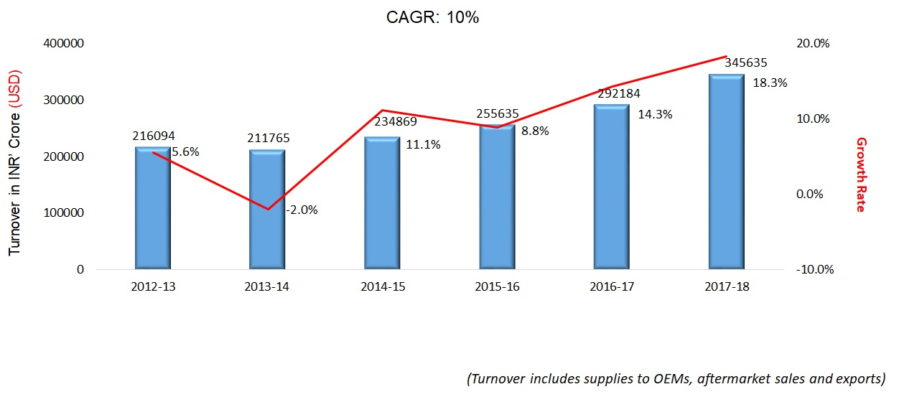

**Summary of Findings:**

***Figures in INR Crores***

|  |  |  |  |  |  |  |
| --- | --- | --- | --- | --- | --- | --- |
|  | **2012-2013** | **2013-2014** | **2014-2015** | **2015-2016** | **2016-2017** | **2017-2018** |
| Turnover | 216,094 | 211,765 | 234,869 | 255,635 | 292,184 | 345,635 |
| Growth% | 5.60% | -2.00% | 11.10% | 8.80% | 14.30% | 18.30% |
| Exports | 52,690 | 61,487 | 68,522 | 70,916 | 73,128 | 90,571 |
| Growth% | 23.30% | 16.70% | 11.40% | 3.50% | 3.10% | 23.90% |
| Imports | 74,463 | 77,160 | 82,931 | 90,662 | 90,571 | 106,672 |
| Growth% | 11.60% | 3.60% | 7.50% | 9.30% | -0.10% | 17.80% |
| Aftermarket | 31,788 | 35,603 | 39,875 | 44,660 | 56,096 | 61,601 |
| Growth% | 7.40% | 12.00% | 12.00% | 12.00% | 25.60% | 9.8 |

***Figures in USD Billion***

|  |  |  |  |  |  |  |
| --- | --- | --- | --- | --- | --- | --- |
|  | **2012-2013** | **2013-2014** | **2014-2015** | **2015-2016** | **2016-2017** | **2017-2018** |
| Turnover | 39.7 | 35.1 | 38.5 | 39 | 43.55 | 51.2 |
| Growth% | -5.90% | -11.50% | 9.60% | 1.30% | 11.70% | 18.30% |
| Exports | 9.7 | 10.2 | 11.22 | 10.81 | 10.9 | 13.5 |
| Growth% | 9.90% | 5.40% | 10.00% | -3.70% | 0.80% | 24% |
| Imports | 13.7 | 12.8 | 13.58 | 13.82 | 13.5 | 15.9 |
| Growth% | -0.60% | -6.40% | 6.10% | 1.80% | -2.30% | 17.8% |
| Aftermarket | 5.8 | 5.9 | 6.5 | 6.8 | 8.4 | 9.2 |
| Growth% | -4.30% | 1.10% | 10.70% | 4.00% | 23.50% | 9.50% |

Note:

*Turnover data represents the entire supplies from the auto component industry (ACMA members and non-members) to the on-road and off-road vehicle manufacturers and the aftermarket in India as well as exports. This also includes component supplies captive to the OEMs and by the unorganized and smaller players.*

**About ACMA:**

The Automotive Component Manufacturers Association of India (ACMA) is the apex body representing the interest of the Indian Auto Component Industry. Its membership of over 800 manufacturers contributes more than 90% of the auto component industry’s turnover in the organized sector. ACMA is an ISO 9001:2008 Certified Association. ACMA has played a pivotal role in supporting its members in export development and in discovering new market opportunities, currently the industry exports to more than 160 countries.

.

**For further details:**

|  |  |
| --- | --- |
| **ACMA**  Harkaran Malhotra  9818388411  [harkaran.malhotra@acma.in](mailto:harkaran.malhotra@acma.in) | **Avian Media**  Saurabh Gupta | M: 9818075578 | E: saurabhgupta@avian-media.com  Stuti Chhabra | M: 9973145222 | E: stuti@avian-media.com |