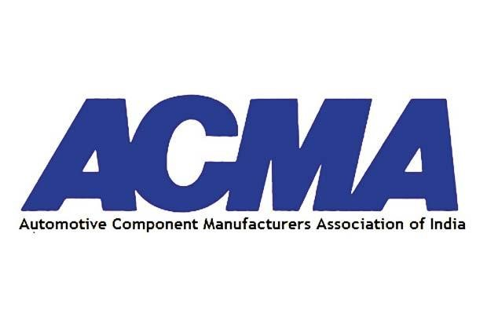

COVERAGE DOSSEIR: June 2020

The month of June witnessed situation where the auto industry recommenced its operations but then the India China dispute gave it a knee-jerk. This created a hurdle in the recovery of the auto sector. Since Auto Component Manufacturers Association (ACMA) is in favour of ‘Vocal for Local’ campaign although some of the components that are imported from China are vital in building the product. We developed narratives to bring attention on the auto component industry by conducting series of interactions across media through virtual and telephonic interviews and disseminated a press release.

- Number of press releases disseminated: 1
- Number of media Interaction coordinated: 5
- Total coverage generated: 75
- Print: 14
- Online: 58
- Electronic: 2
- Webinar: 2

Activity 1:
We disseminated a press release on ‘On Import Congestion’

Key messages landed:
- Auto component industry in India is committed to the ‘Atma-Nirbhar vision’
- Non availability of a single component can hinder the recovery

Result: We were able to garner a total of 20 stories and coverage. The coverages were garnered
in tier-1 portable like Business Standard, The Hindu, ET Auto, Financial Express, etc. and a Print coverage in The Hindu, The Times of India, etc.

Activity 2:
We arranged an interaction with Mr. Nishant Sharma, from Bloomberg Quint on ‘The low paid jobs and labour issue’

Key messages:
- Long-pending demands on GST to be 18%
- Auto markets needs recovery or else firms catering to commercial vehicles will get shut

Results: The story appeared on the virtual and print platform.

Activity 3:
We planned an electronic interaction with the ET Now which lasted for 37 minutes on the topic ‘India's dependence on China’.

Key messages:
- need to generate job opportunities
- Bring in investments
- Need to adopt self- reliance
- Need to bifurcate political and business stance

Results: The interaction aired for 37 minutes which appeared on the show called "India Development Debate".
Activity 4:
We planned a video interaction with Mr. Pranbihanga Borpuzari, Associate Editor, from Economic Times.com

on ‘Wary of public transport, Covid-19 may drive up demand for entry level vehicles, 2-wheelers.

Key messages:
- In the Auto sector the capacity utilisation was 8-10%
- Challenge of temporary workers is more in smaller companies

Results: The coverage aired in the on ET Rise for 25 minutes.

Activity 5:
We planned a telephonic interaction with Arshad Khan from New Indian Express on ‘India China trade issue’

Key messages:
- Auto Components worried about the delay
- Hampering of their imports

Results: The coverage appeared in the New Indian Express.

Coverage Snapshots

Coverage Grid
S.No | Publications | Headline
Electronic
 | ET Now | India Development Debate
 | ET Rise | Wary of public transport, Covid-19 may drive up demand for entry level vehicles, 2-wheelers
 |  | Webinar/Panel discussion
 | Mint | '3 big challenges' for auto parts sector amid Covid: ACMA president explains;
 | Auto Tech Review | Effects of New Normal on Mobility Industry
Print
 | The Times of India | Curbs on Chinese imports to hit the mfg ops, parts supply: Auto cos
 | The Hindu | Auto exports tumble 73% on lockdown, delayed orders
 | The Hindu | Auto, Pharma unready to wean off China
 | Business Standard | Automobiles companies says disruption in Chinese imports will hurt their recovery
 | Business Standard | India plans incentives to double auto exports
 | Business Line | Do not delay clearance of imported Chinese components: Auto Industry
 | Business Line | Auto sector must take a pause and recalibrate: ACMA Chief
 | The Financial Express | Imports clearance delay to hit production: SIAM, ACMA
 | Mint | Lenders see small and medium business making a recovery soon
 | Pioneer | Delay in import clearance may impact vehicle production
 | Free Press Journal | Import clearance delay may impact auto output
 | Free Press Journal | Auto component should aim for 5% of global trade in 5yrs: ACMA
 | Deccan Chronicle | Manual checking to hurt production: Auto bodies
 | DT Next | Auto comp biz target $ 1.3 trillion mark in 5 years: ACMA
Online
 | New York Times | Exclusive: India Plans Incentives for Auto Companies to Boost Exports-Sources
 | The Times of India | Govt plans incentives for auto companies to boost exports: Sources
 | The Times of India | Curbs on Chinese imports to hit mfg ops: Auto cos
 | The Times of India | Auto component industry should aim for 5% of global trade in 5 years: ACMA
 | The Hindu | Auto exports tumble 73% on lockdown, delayed orders
 | Indian Express | India coronavirus updates, 07 June: Coronavirus situation under control but can’t allow violation of safety measures, says Punjab CM
 | New Indian Express | Two-wheeler sales see sharp improvement
 | New Indian Express | Indian auto component industry aims to cut dependence on Chinese imports: ACMA
 | New Indian Express | Auto components makers fear delay in imports clearance may impact vehicle production
 | India Today | India's auto, pharma sectors not ready to wean off China
 | Business Today | Auto manufacturers fear further disruption with imports from China stuck at ports
 | Business Today | Auto, pharma sectors not ready to boycott China
 | Business Standard | Auto industry bodies fear delay in imports clearance may impact production
 | Business Standard | Finding alternatives to China not easy, caution auto manufacturers
 | Economic Times | Indian auto component industry aims to cut dependence on Chinese imports: ACMA
 | Economic Times | Auto industry lobbies appeal against 100% inspection of Chinese imports
 | Economic Times | Auto component industry should aim for 5 pc of global trade in 5 yrs; govt support crucial: ACMA
 | Economic Times | Huge job losses imminent if demand remains weak: ACMA
 | ET Auto | ACMA fears supply chain disruption due to delay in clearance of Chinese imports
 | ET Auto | Auto component industry may end current fiscal in negative territory: ACMA
 | HT Auto | India plans incentives for auto companies to boost exports: Sources
 | HT Auto | India's auto sector not ready to quit China habit
 | Hindu Business Line | Do not delay clearance of imported Chinese auto components: Auto industry
 | Hindu Business Line | Auto sector must take a pause and recalibrate: ACMA chief
 | Hindu Business Line | GST rate cut for vehicles is a low-hanging fruit to drive demand: ACMA President
 | Live Mint | Govt should help in creating demand to help MSMEs get out of pandemic crisis: ACMA’s Deepak Jain
 | Live Mint | Pivot or Perish: India should focus on improving local manufacturing in next few years
 | Live Mint | Lenders see small and medium businesses making a recovery soon
 | Live Mint | India's auto and pharma sectors not ready to wean off China
 | Live Mint | Consumer demand needs to pick up for the key sector to stay afloat
 | Financial Express | Vehicle production will be impacted due to delay in Chinese component imports: SIAM backs ACMA
 | Financial Express | SIAM, ACMA fear impact on vehicle production due to delay in imports clearance, here’s why
 | Financial Express | Huge job losses near if demand continues to be weak: ACMA
 | Bloomberg Quint | The Pandemic Hastens Automation of Low-Paid Jobs For Auto Parts Suppliers
 | Bloomberg Quint | Auto-Parts Makers Expect Short-Term Pain If Chinese Imports Get Costlier
 | Financial Post | India plans incentives for auto companies to boost exports-sources
 | Money Control | Manual inspection of imports from China leading to delays: Auto parts association, SIAM
 | Money Control | Huge job losses imminent if demand remains weak: ACMA
 | The Outlook | Auto industry bodies fear delay in imports clearance may impact vehicle production
 | The Outlook | Indian auto component industry aims to cut dependence on Chinese imports: ACMA
 | The Outlook | Huge job losses imminent if demand remains weak: ACMA
 | The Outlook | Auto component industry should aim for 5 pc of global trade in 5 yrs; govt support crucial: ACMA
 | NDTV | India's Auto, Pharma Sectors Not Ready To Wean Off China
 | CNBC TV18 | Deep salary cuts and job losses in India’s auto components industry
 | News 18 Auto | Govt to Roll Out Incentives for Auto Companies to Double Exports in Next Five Years
 | Times Now News | Chinese imports held up at ports will disrupt supply chain: Indian auto industry
 | The Pioneer | ‘Delay in imports clearance may impact vehicle production’
 | Deccan Herald | Centre mulls ban on import of nonessentials from China
 | Deccan Chronicle | Huge job losses imminent in automotive sector if demand remains weak: ACMA
 | Telangana Today | Huge job losses imminent if demand remains weak: ACMA
 | In Shorts | Auto industry planning deep localisation to cut China imports: ACMA
 | BS Motoring | Disruptions in Chinese imports will hurt their recovery: Automobile firms
 | Auto Tech Review | ACMA, SIAM Call for Quicker Clearance of Chinese Imports
 | Auto Car Professional | ACMA and SIAM flag off supply chain issues due to delay in getting Chinese-made parts
 | Auto Car Professional | ACMA's Deepak Jain: 'It'll now be survival of the fittest and the need to collaborate to stay relevant.'
 | Auto Car Professional | Continuing headwinds for India Auto Inc could mean huge job losses: ACMA
 | Car and Bike | Congestion Of Auto Components Imported From China May Lead To Production Delays
 | Rush Lane | Lakhs of jobs may be lost in auto component industry this year

Electronic (2)
Publication – ET Now

Headline- India Development Debate

On India Development Debate, The Ministry of External Affairs has put out a statement today reiterating that it was unilateral action by China that resulted in the clash at the LAC, they have clarified no troops are missing. And commander level communication is being maintained. Meanwhile big things are brewing back home. The national discourse has turned to how India's dependence on Chinese imports can be reduced.

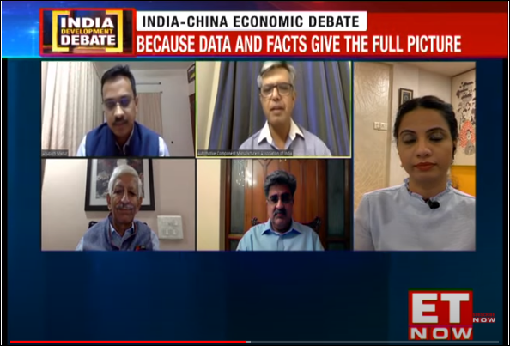

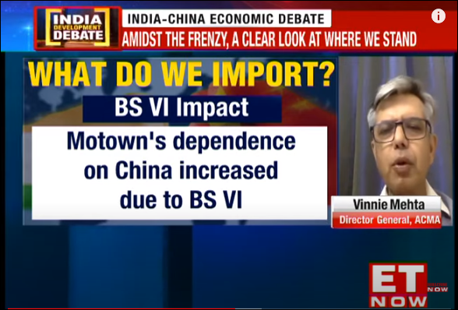

Publication – ET Rise

Headline- Wary of public transport, Covid-19 may drive up demand for entry level vehicles, 2-wheelers

For a battered auto sector, the need for social distancing may prove to be a silver lining. In an environment where people are wary of taking public transport, investing in a personal vehicle may be the only choice left.

Video Interaction (2)

Publication- Live mint
Headline- '3 big challenges' for auto parts sector amid Covid: ACMA president explains

Cash, labour, and raw material - these were highlighted as the main challenges facing the automotive components sector in India, by Deepak Jain, President, Automotive Component Manufacturers Association. Jain was speaking at a webinar of Mint's Pivot Or Perish series. The latest episode focused on India's micro, small and medium enterprises, and how they're dealing with the Covid-19 crisis. Jain said that special attention needed to be paid to boosting demand.
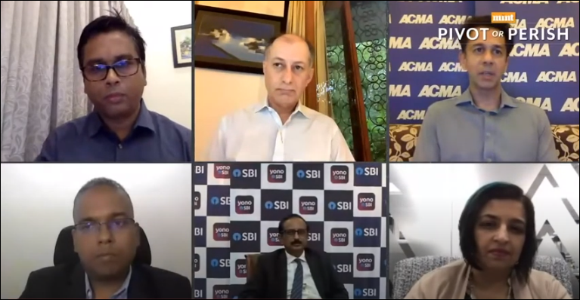
Publication – Auto Tech Review
Headline - Effects of New Normal on Mobility Industry

The impact of COVID-19 on the manufacturing and consumers goods industry. Respective participants conversed about the new economic stimulus and vocal for local.

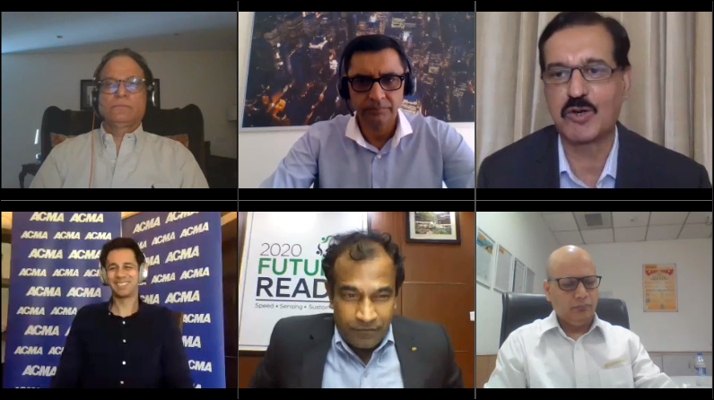

Print (14)
Publication – The Times of India
Headline – Curbs on Chinese imports to hit the mfg ops, parts supply: Auto cos

After telecom, the auto industry has raised a red flag over sudden restrictions on imports from China and subjecting parts and consignments to rigorous checks at ports, saying this would disrupt manufacturing in the sector at a time when it is struggling with the corona-induced slowdown. The objections have been made by companies as well as industry associations.

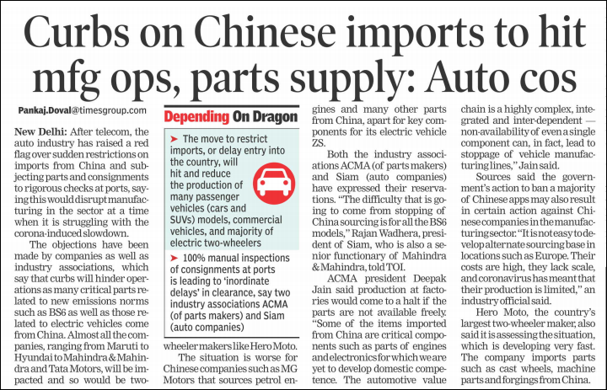

Publication – The Hindu
Headline - Auto exports tumble 73% on lockdown, delayed orders

Import consignments from China are being subjected to ‘100% manual inspection, resulting in clearance delays’ amid continuing border tensions between India and its northern neighbour.
“Inordinate delays in clearance due to congestions at ports could eventually impact manufacturing of vehicles in India,” Rajan Wadhera, president, Society of Indian Automobile Manufacturers, said.
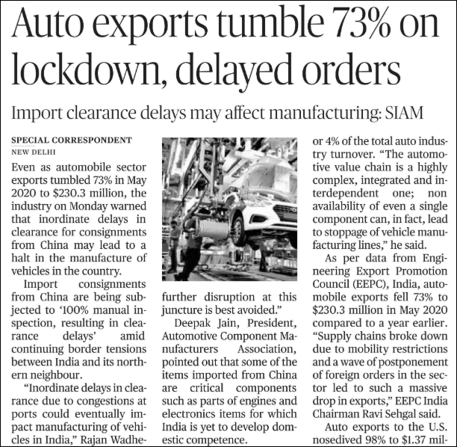

Publication – The Hindu
Headline – Auto, Pharma unready to wean off China

Days after a border clash with China this month in which 20 Indian soldiers were killed, New Delhi told firms to find ways to cut imports from China. But two big industries, automobiles, and pharmaceuticals, say this is easier said than done. Like many countries, India relies on China for products such as electronic components and drug ingredients because it cannot make them or source them elsewhere as cheaply, company and industry figures say.
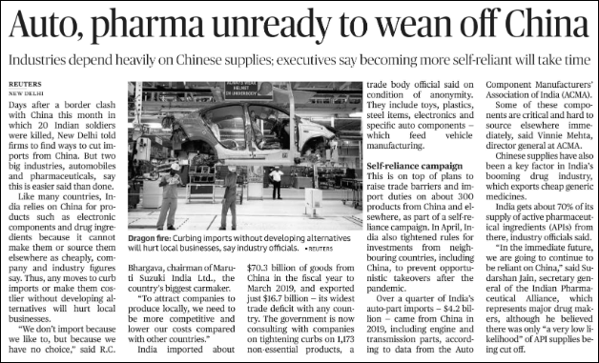
Publication – Business Standard
Headline – Automobiles companies says disruption in Chinese imports will hurt their recovery
The Indian automobile industry has sounded alarm bells over delays in Customs clearance for imports from China. The move, they said, would hurt the recovery of the industry, which has been reeling from the shock of a yearlong slowdown further worsened by the Covid-19 pandemic.

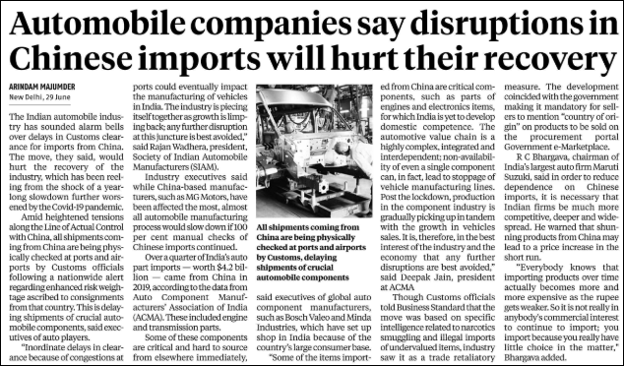
Publication- Business Standard
Headline - India plans incentives to double auto exports

India is drawing up an incentive scheme for the autos sector aimed at doubling exports of vehicles and components in the next five years, four sources with direct knowledge of the matter told Reuters The Department of Heavy Industries (DHI) has sought feedback from auto industry groups on the initial proposal.
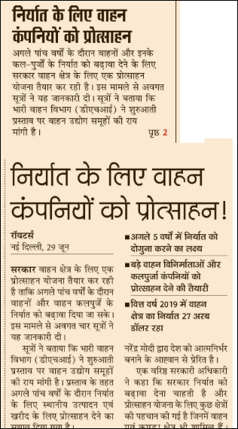
Publication – Business line
Headline- Do not delay clearance of imported Chinese components: Auto Industry

The auto industry on Monday urged that the manual inspection of imported consignments from China should be avoided as that is delaying manufacturing of automobiles. The Society of Indian Automobile Manufacturers (SIAM) and the Automotive Component Manufacturers Association of India (ACMA) have said that this will also further slowdown the economy as auto industry is a major contributor to the GDP.

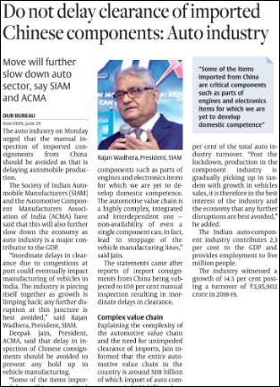

Publication – Business Line
Headline – Auto sector must take a pause and recalibrate: ACMA Chief

With Unlock 1.0 now underway, Deepak Jain feels the auto industry could do well without any disruptions for a while. In his dual role as President of ACMA (Automotive Component Manufacturers Association) and Chairman & MD of Lumax Industries, he had his hands full during the near 70-day lockdown.
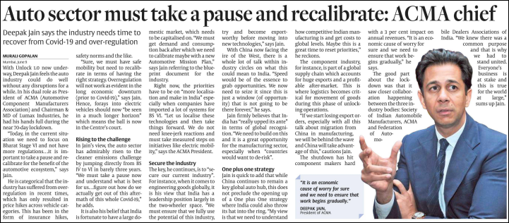

Publication – Business Line
Headline – GST rate cut for vehicles is a low-hanging fruit to drive demand: ACMA President

With the Indian automotive industry expected to hit decadal-low volumes this fiscal due to the Covid-19 pandemic, the outlook for the auto component sector is bleak in the near term. While auto-parts makers across clusters have restarted their operations, challenges remain in scaling up their operations from both the supply and demand sides. Deepak Jain, President, Automotive Component Manufacturers’ Association of India (ACMA).

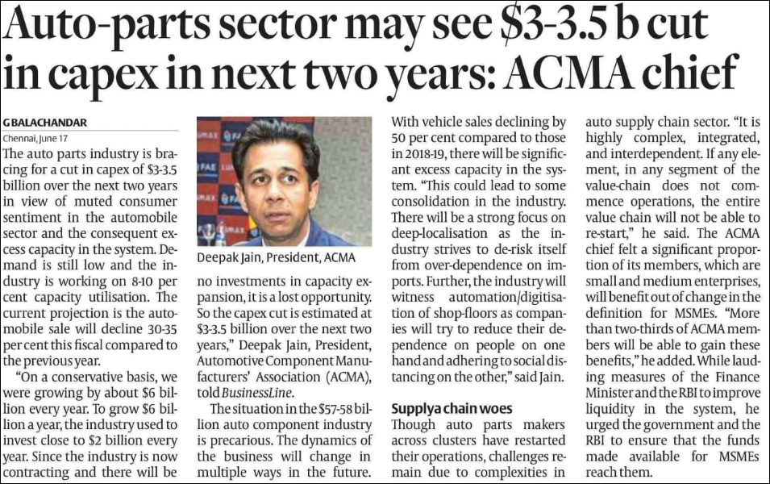

Publication – The Financial Express
Headline – Imports clearance delay to hit production: SIAM, ACMA

Automotive industry bodies SIAM and ACMA on Monday sought timely clearance of imports in ports, stressing that inordinate delay in port clearances across the country, due to manual inspections, would put further pressure on the industry in terms of manufacturing. Society of Indian Automobile Manufacturers (SIAM) president Rajan Wadhera said, “Inordinate delays in clearance due to congestions in ports could eventually impact manufacturing of vehicles in India. The industry is piecing itself together as growth is limping back.

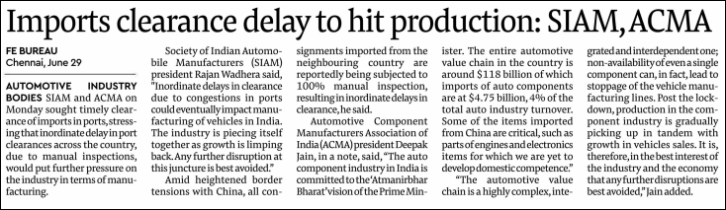

Publication – Mint
Headline – Lenders see small and medium business making a recovery soon

Deepak Jain, president of the Automotive Component Manufacturers Association (ACMA) of India, said he is “optimistic" of a recovery, pointing to the role of direct benefit transfers in farmer welfare and rising tractor sales. He added that the current focus is to keep shop floors running despite muted demand and rising costs. Against the backdrop of rising nationalist sentiments after 20 Indian soldiers died in a border conflict with China, panelists cautioned against any knee-jerk reaction.

Publication- Pioneer
Headline – Delay in import clearance may impact vehicle production

Earlier in the day auto components makers body ACMA had sought timely clearance of imports from China, saying that delay in clearing such items could lead to disruption in vehicle manufacturing across the country.

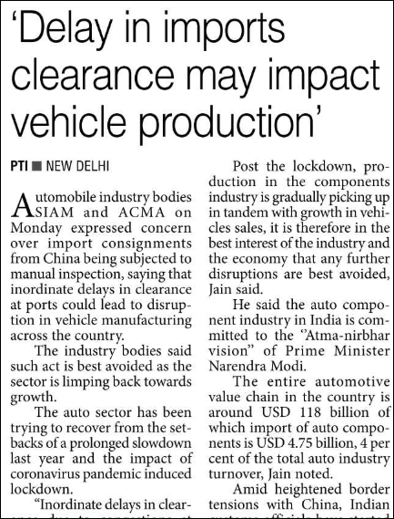

Publication- Free Press Journal
Headline – Auto component should aim for 5% of global trade in 5yrs: ACMA

The Indian auto components industry should look at enhancing exports and target at least 5 per cent of the total global trade, which stands at around USD 1.3 trillion, in the next five years, according to a top industry executive.
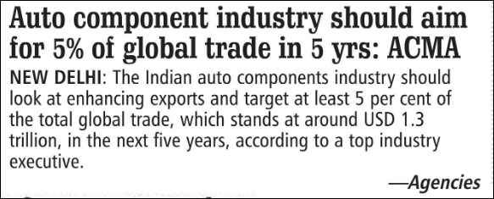

Publication- Deccan Chronicle
Headline – Manual checking to hurt production: Auto bodies

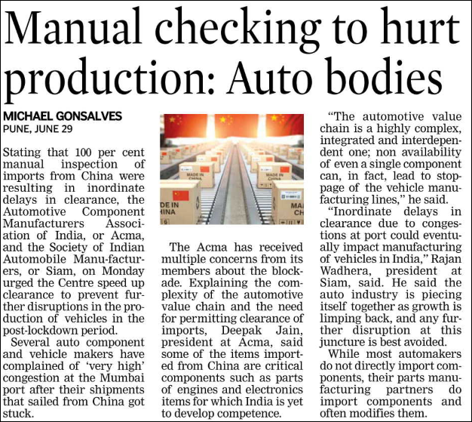
Stating that 100 per cent manual inspection of imports from China were resulting in inordinate delays in clearance, the Automotive Component Manufacturers Association of India, or Acma, and the Society of Indian Automobile Manufacturers, or Siam, on Monday urged the Centre speed up clearance to prevent further disruptions in the production of vehicles in the post-lockdown period.
Publication- Free Press Journal
Headline – Auto comp biz target $ 1.3 trillion mark in 5 years: ACMA

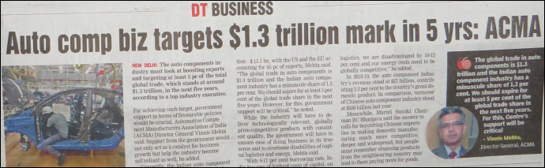
For achieving such target, government support in terms of favourable policies would be crucial, Automotive Component Manufacturers Association of India (ACMA) Director General Vinnie Mehta said. Support from the government would not only act as a catalyst for business growth but help the industry become self-reliant as well, he added.

Online (76)

Publication- New York Times
Headline- Exclusive: India Plans Incentives for Auto Companies to Boost Exports-Sources

India is drawing up an incentive scheme for the autos sector aimed at doubling exports of vehicles and components in the next five years, four sources with direct knowledge of the matter told Reuters. The Department of Heavy Industries (DHI) has sought feedback from auto industry groups on the initial proposal, which suggests giving incentives over five years to increase local production and procurement for export, the sources said.

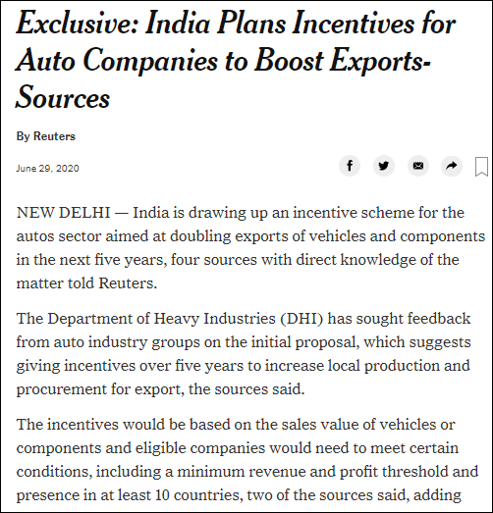

Publication – Times of India
Headline -Govt plans incentives for auto companies to boost exports: Sources

India is drawing up an incentive scheme for the autos sector aimed at doubling exports of vehicles and components in the next five years, four sources with direct knowledge of the matter told Reuters. The Department of Heavy Industries (DHI) has sought feedback from auto industry groups on the initial proposal, which suggests giving incentives over five years to increase local production and procurement for export, the sources said.
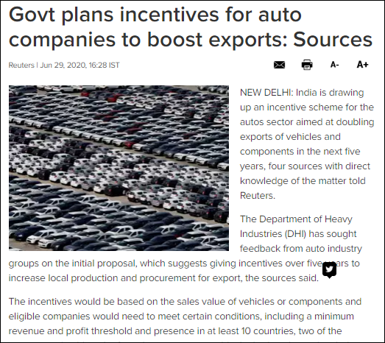
Publication – Times of India
Headline - Curbs on Chinese imports to hit mfg ops: Auto cos

After telecom, the auto industry has raised a red flag over sudden restrictions on imports from China and subjecting parts and consignments to rigorous checks at ports, saying this would disrupt manufacturing in the sector at a time when it is struggling with the corona-induced slowdown.
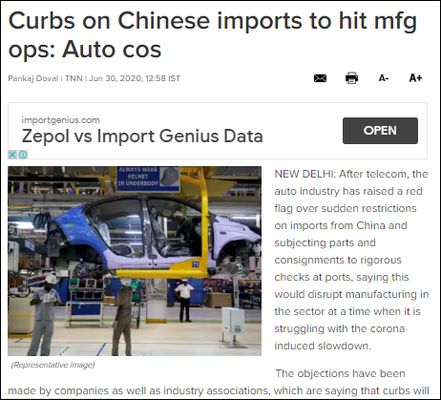
Publication – Times of India
Headline - Auto component industry should aim for 5% of global trade in 5 years: ACMA

The Indian auto components industry should look at enhancing exports and target at least 5 per cent of the total global trade, which stands at around $1.3 trillion, in the next five years, according to a top industry executive. For achieving such target, government support in terms of favourable policies would be crucial.

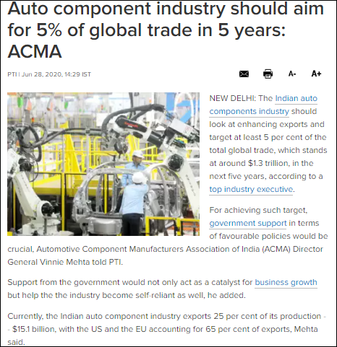
Publication- The Hindu
Headline - Auto exports tumble 73% on lockdown, delayed orders

Even as automobile sector exports tumbled 73% in May 2020 to $230.3 million, the industry on Monday warned that inordinate delays in clearance for consignments from China may lead to a halt in the manufacture of vehicles in the country.
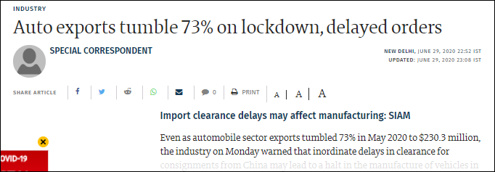
Publication- Indian Express
Headline-India coronavirus updates, 07 June: Coronavirus situation under control but can’t allow violation of safety measures, says Punjab CM

The auto component sector may see huge job losses if the automotive sector continues to face headwinds due to lack of demand amid coronavirus pandemic, industry body ACMA has said.
With muted demand and excess capacities already in place, the auto component makers would have to cut down on their workforce to keep their businesses afloat, the industry body added.
Publication- New Indian Express
Headline -Two-wheeler sales see sharp improvement

Two-wheeler companies have reported a substantial improvement in June 2020 sales, according to data released by the companies. Royal Enfield reported selling 36,510 motorcycles in June 2020 in the domestic market compared to 55,082 units last year. While sales declined 34% year-on-year, the company had sold 18,429 units in May 2020.

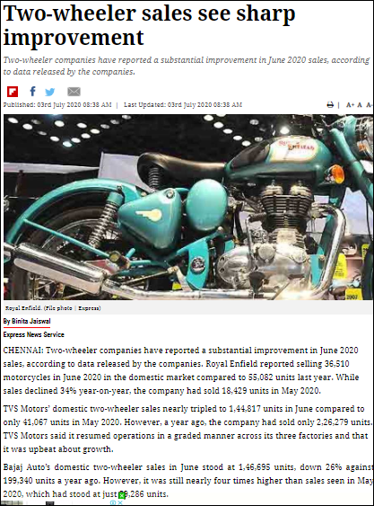
Publication- New Indian Express
Headline- Indian auto component industry aims to cut dependence on Chinese imports: ACMA

The USD 57 billion-Indian auto component industry has started taking steps towards "deep localisation" to de-risk business from Chinese imports with the border dispute between the two countries only acting as a catalyst to speed up the process, according to industry body ACMA.
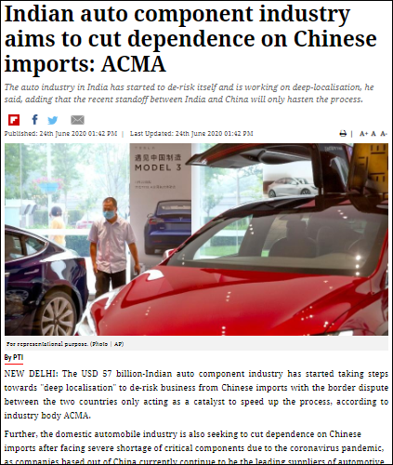
Publication – New Indian Express
Headline - Auto components makers fear delay in imports clearance may impact vehicle production

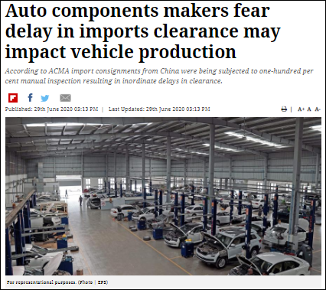
Auto component industry body ACMA on Monday sought timely clearance of imports from China, saying that delay in clearing such items could lead to disruption in vehicle manufacturing across the country.
Publication – India Today

Headline- India's auto, pharma sectors not ready to wean off China

Days after a border clash with China this month in which 20 Indian soldiers were killed, New Delhi told firms to find ways to cut imports from China. But two big industries, automobiles, and pharmaceuticals, say this is easier said than done.

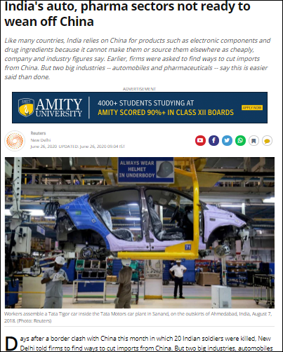

Publication- Business Today
Headline - Auto manufacturers fear further disruption with imports from China stuck at ports

Reports of import consignments getting stuck at ports is making India's domestic automobile industry nervous. India's $118 billion automobile industry is largely self-reliant but still depends on imports for a few critical components especially in electronics that are not produced on a large scale in the country.
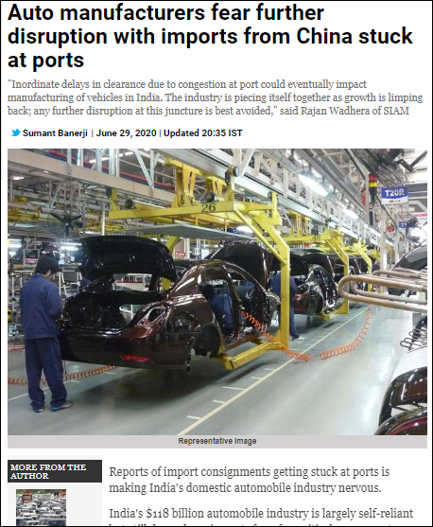
Publication- Business Today
Headline- Auto, pharma sectors not ready to boycott China

Welcoming the announcement made by PM, the Indian auto industry believes the Rs. 20 lakh crore- package strengthens the dream of a resilient India and is a progressive step towards a great India. Most of the industry stalwarts have also expressed hope that the contours of the package to be announced by Finance Minister Nirmala Sitharaman (at 4pm on 13th) will address the needs of the poor and needy
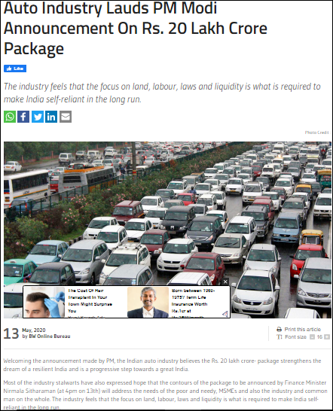
Publication: Business Standard
Headline: After a washout month, automobile industry seeks resumption of business

Days after a border clash with China this month in which 20 Indian soldiers were killed, New Delhi told firms to find ways to cut imports from China. But two big industries, automobiles and pharmaceuticals, say this is easier said than done. Like many countries, India relies on China for products such as electronic components and drug ingredients because it cannot make them or source them elsewhere as cheaply,
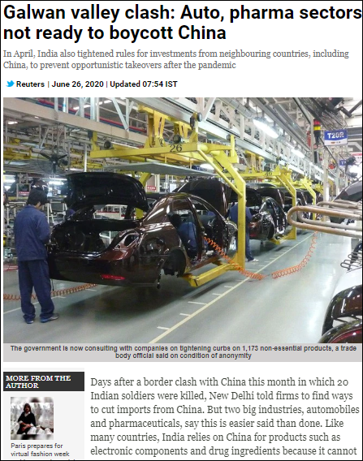

Publication: Business Standard
Headline: Auto industry bodies fear delay in imports clearance may impact production

Automobile industry bodies SIAM and ACMA on Monday expressed concern over import consignments from China being subjected to manual inspection, saying that inordinate delays in clearance at ports could lead to disruption in vehicle manufacturing across the country.

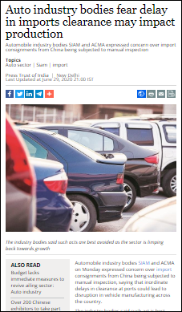

Publication: Business Standard
Headline: Finding alternatives to China not easy, caution auto manufacturers
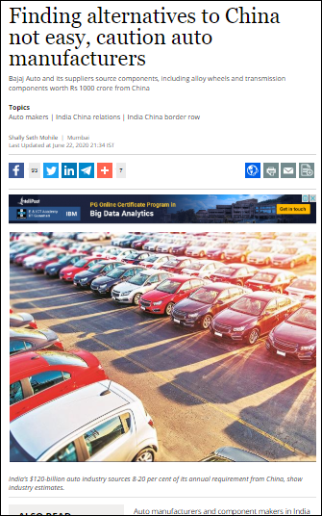
Auto manufacturers and component makers in India have sounded a note of caution against the rising call to boycott Chinese products. A knee-jerk reaction, they said, could be detrimental to the fortunes of an industry that is highly dependent on the country given the huge competitive advantage it offers, in terms of cost and speed.

Publication: Economic Times
Headline: Indian auto component industry aims to cut dependence on Chinese imports: ACMA

The USD 57 billion-Indian auto component industry has started taking steps towards "deep localisation" to de-risk business from Chinese imports with the border dispute between the two countries only acting as a catalyst to speed up the process, according to industry body ACMA.

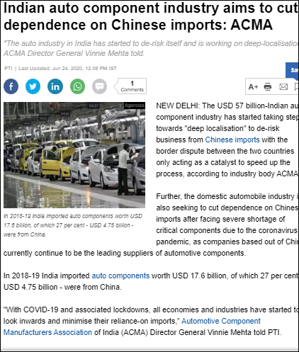

Publication: Economic Times
Headline: Auto industry lobbies appeal against 100% inspection of Chinese imports

Two of the top automotive industry lobbies on Monday appealed to the government against the 100% manual inspection of Chinese goods at ports because it was hurting the industry’s production schedules at a time when companies were trying to get their supply chains back in order after the lockdown to contain the coronavirus pandemic.

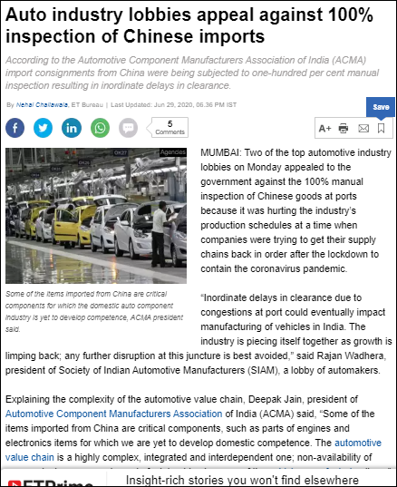

Publication: Economic Times
Headline: Auto component industry should aim for 5 pc of global trade in 5 yrs; govt support crucial: ACMA

The Indian auto components industry should look at enhancing exports and target at least 5 per cent of the total global trade, which stands at around USD 1.3 trillion, in the next five years, according to a top industry executive.
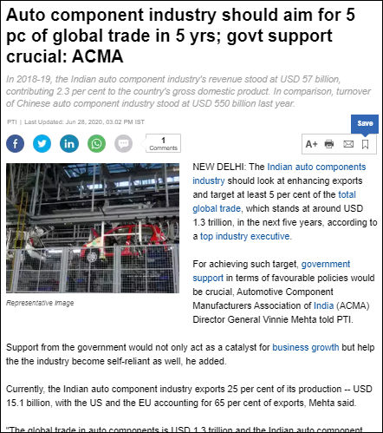

Publication: Economic Times
Headline: Huge job losses imminent if demand remains weak: ACMA

Auto component sector may see huge job losses if the automotive sector continues to face headwinds due to lack of demand amid coronavirus pandemic, industry body ACMA has said. With muted demand and excess capacities already in place, the auto component makers would have to cut down on their workforce in order to keep their businesses afloat, the industry body added.

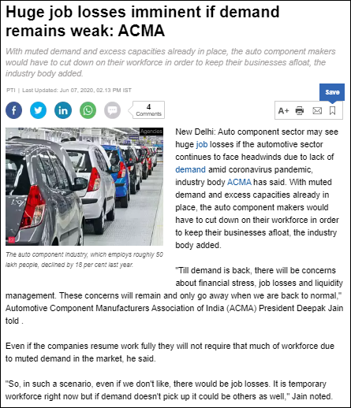

Publication: ET Auto
Headline: ACMA fears supply chain disruption due to delay in clearance of Chinese imports

Delay in clearances for imports from China has started wreaking havoc on the operation of Indian auto industry. Auto component body ACMA on Monday urged the authorities for timely clearance of imports from China in a bid to avoid supply-chain disruption in vehicle manufacturing.
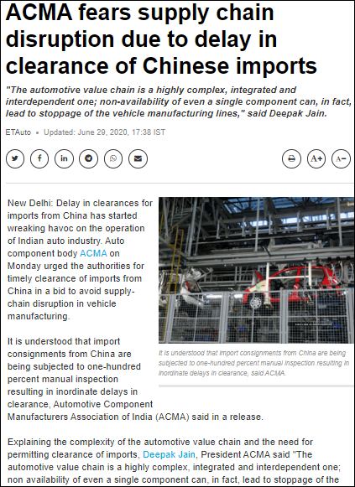

Publication: ET Auto
Headline- Auto component industry may end current fiscal in negative territory: ACMA

The automobile component industry is expected to end the current financial year on a negative note as it would be difficult for the segment to make a recovery in the second half after reporting a de-growth of 10 per cent in the first six months, ACMA President Deepak Jain said.

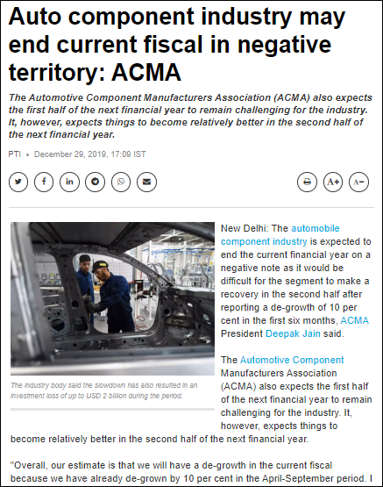

Publication: HT Auto
Headline: India plans incentives for auto companies to boost exports: Sources

The Department of Heavy Industries (DHI) has sought feedback from auto industry groups on the initial proposal, which suggests giving incentives over five years to increase local production and procurement for export, the sources said. The incentives would be based on the sales value of vehicles or components and eligible companies would need to meet certain conditions

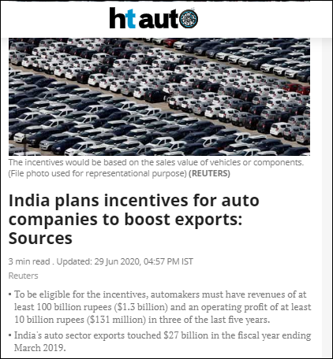

Publication: HT Auto
Headline: India's auto sector not ready to quit China habit

Days after a border clash with China this month in which 20 Indian soldiers were killed, New Delhi told firms to find ways to cut imports from China. But two big industries, automobiles, and pharmaceuticals, say this is easier said than done.

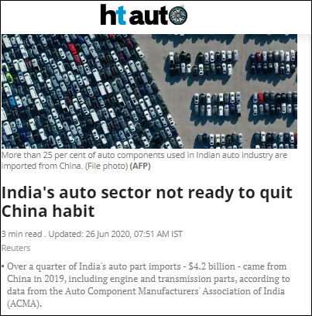

Publication: Hindu Business Line
Headline: Do not delay clearance of imported Chinese auto components: Auto industry

The auto industry on Monday urged that the manual inspection of imported consignments from China should be avoided as that is delaying manufacturing of automobiles. The Society of Indian Automobile Manufacturers (SIAM) and the Automotive Component Manufacturers Association of India (ACMA) have said that this will also further slowdown the economy as auto industry is a major contributor to the GDP.

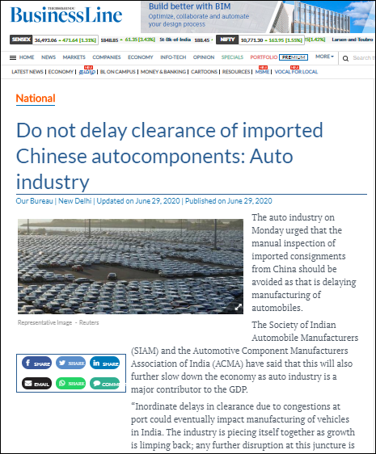

Publication: Hindu Business Line
Headline: Auto sector must take a pause and recalibrate: ACMA chief

With Unlock 1.0 now underway, Deepak Jain feels the auto industry could do well without any disruptions for a while. In his dual role as President of ACMA (Automotive Component Manufacturers Association) and Chairman & MD of Lumax Industries, he had his hands full during the near 70-day lockdown.

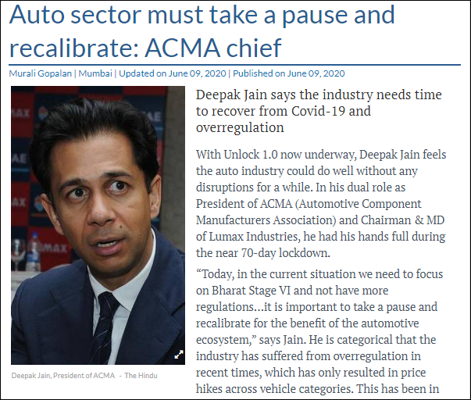

Publication- Hindu business Line
Headline: GST rate cut for vehicles is a low-hanging fruit to drive demand: ACMA President

With the Indian automotive industry expected to hit decadal-low volumes this fiscal due to the Covid-19 pandemic, the outlook for the auto component sector is bleak in the near term. While auto-parts makers across clusters have restarted their operations, challenges remain in scaling up their operations from both the supply and demand sides. Deepak Jain, President, Automotive Component Manufacturers’

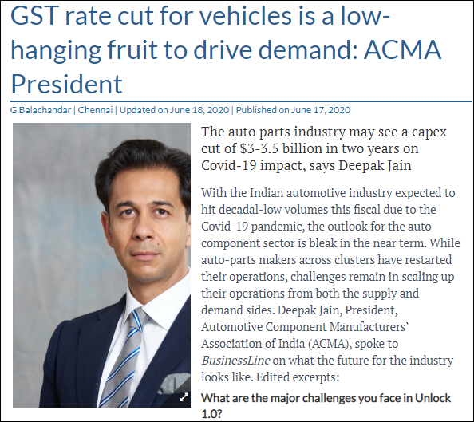

Publication: Live Mint
Headline: Govt should help in creating demand to help MSMEs get out of pandemic crisis: ACMA’s Deepak Jain

In order to help the tier two and three component manufacturers survive this Covid-19 induced economic slowdown, the union government should help create demand in the domestic market which will translate into more business for these entities, said Deepak Jain, president Automotive Component Manufacturers Association of India (ACMA) at Mint’s Pivot or Perish webinar on Thursday.

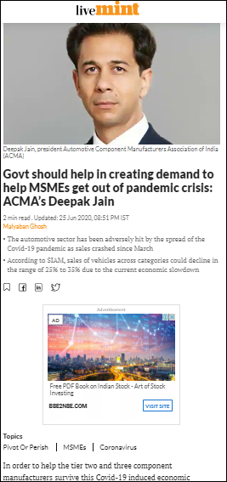

Publication: Live Mint
Headline: Pivot or Perish: India should focus on improving local manufacturing in next few years

India should try to localize most of the goods that are presently imported from China in the next few years but the Centre should balance emotion with the economy while devising ways to counter China immediately, said executives at Mint’s Pivot and Perish webinar on Thursday.

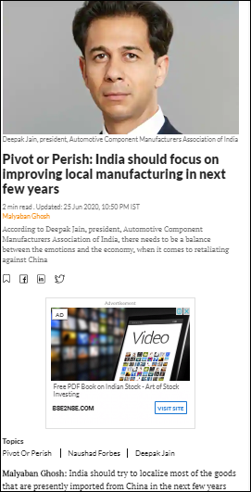

Publication: Live Mint
Headline: Lenders see small and medium businesses making a recovery soons

Small businesses may struggle with cash flows once the loan moratorium is over, but the future is not all gloom and doom for them, panelists at Mint’s Pivot or Perish webinar on micro, small and medium enterprises (MSMEs) said.

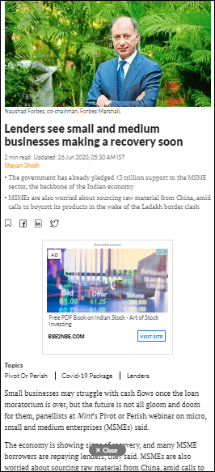

Publication: Live Mint
Headline: India's auto and pharma sectors not ready to wean off China

Days after a border clash with China this month in which 20 Indian soldiers were killed, New Delhi told firms to find ways to cut imports from China. But two big industries, automobiles and pharmaceuticals, say this is easier said than done. Like many countries, India relies on China for products such as electronic components.
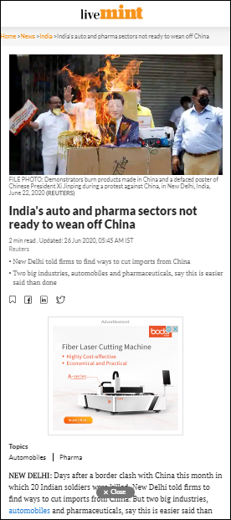

Publication: Live Mint
Headline: Consumer demand needs to pick up for the key sector to stay afloat

While easy access to affordable credit is an important factor in helping small businesses stay afloat, any improvement in their prospects will not happen till consumer demand picks up. Speakers at the Mint’s Pivot or Perish webinar on the MSME sector said the Centre must step in to ensure increased spending for demand to return.
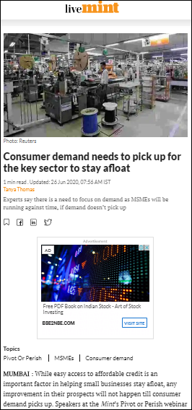

Publication: Financial Express
Headline: Vehicle production will be impacted due to delay in Chinese component imports: SIAM backs ACMA

Automotive Component Manufacturers Association of India (ACMA) has issued a statement regarding the possible impact on vehicle production due to delays in component imports from China. The statement comes following the government’s decision to subject import consignments from China to 100 percent manual inspection, resulting in inordinate delays in clearance.

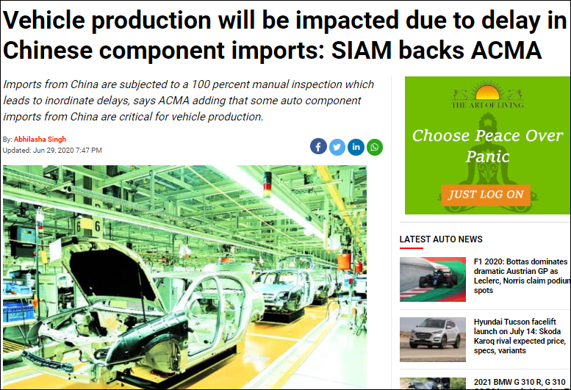

Publication: The Financial Express
Headline: SIAM, ACMA fear impact on vehicle production due to delay in imports clearance, here’s why

Automotive industry bodies SIAM and ACMA on Monday sought timely clearance of imports in ports, stressing that inordinate delay in port clearances across the country, due to manual inspections, would put further pressure on the industry in terms of manufacturing.
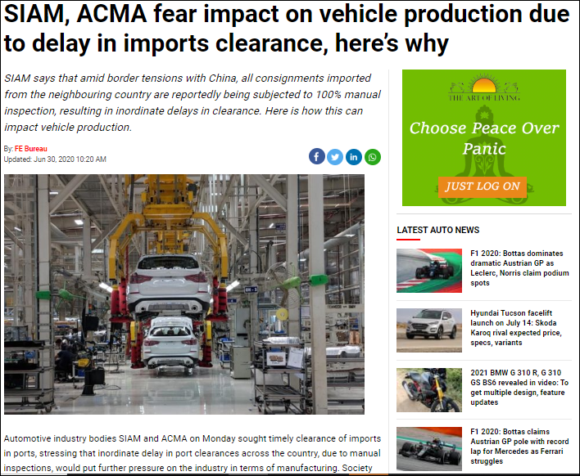

Publication: The Financial Express
Headline: Huge job losses near if demand continues to be weak: ACMA

Auto component sector may see huge job losses if the automotive sector continues to face headwinds due to lack of demand amid the ongoing coronavirus aka Covid-19 pandemic, industry body ACMA has said. With muted demand and excess capacities already in place, the auto component makers would have to cut down on their workforce to keep their businesses afloat, the industry body added

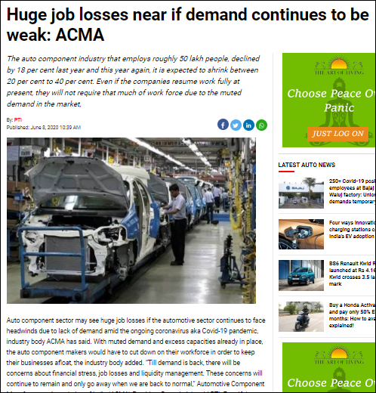

Publication: Bloomberg Quint
Headline: The Pandemic Hastens Automation of Low-Paid Jobs For Auto Parts Suppliers

When Sunil Arora planned to restart his auto-parts factory in Ghaziabad, just outside Delhi, nearly two months ago, he anticipated fewer workers would turn up. Many of them had returned home after India’s lockdown to contain Covid-19 froze economic activity and prompted a mass exodus unseen since the partition. Amid uncertainty about a recovery, the supplier of pistons, piston-rings and castings

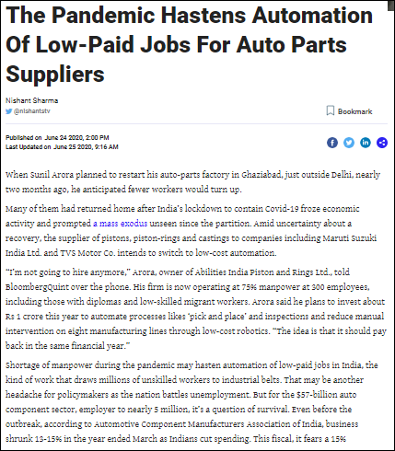

Publication: Bloomberg Quint
Headline: Auto-Parts Makers Expect Short-Term Pain If Chinese Imports Get Costlier

India’s plan to curb Chinese imports can put pressure on its auto components industry that’s already grappling with the effects of a prolonged slowdown and virus-induced shutdown. The Bureau of Indian Standards is considering tougher import norms for at least 370 items that can be locally produced, Bloomberg reported on Thursday, citing unnamed officials. Discussions are also on to raise import
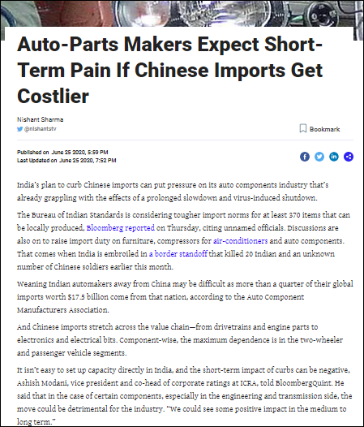

Publication: Financial Post
Headline: India plans incentives for auto companies to boost exports-sources

India is drawing up an incentive scheme for the autos sector aimed at doubling exports of vehicles and components in the next five years, four sources with direct knowledge of the matter told Reuters. The Department of Heavy Industries (DHI) has sought feedback from auto industry groups on the initial proposal, which suggests giving incentives over five years to increase local production and procurement for export, the sources said.
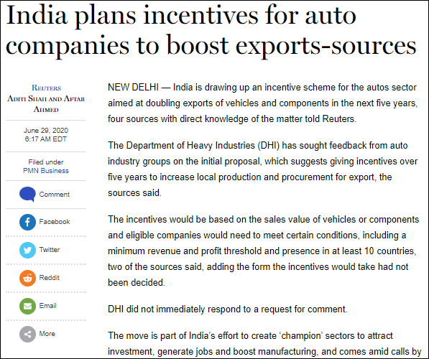

Publication: Money Control
Headline: Manual inspection of imports from China leading to delays: Auto parts association, SIAM

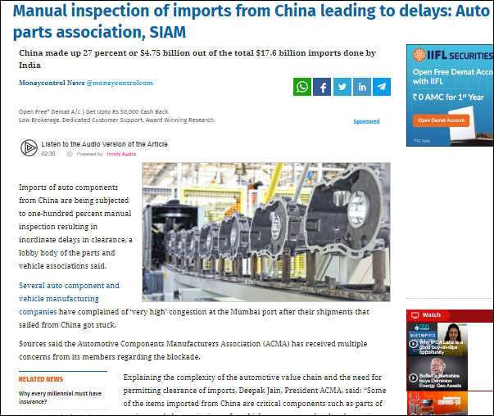
imports of auto components from China are being subjected to one-hundred percent manual inspection resulting in inordinate delays in clearance, a lobby body of the parts and vehicle associations said. Several auto component and vehicle manufacturing companies have complained of ‘very high’ congestion at the Mumbai port after their shipments that sailed from China got stuck. Sources said the Automotive Components Manufacturers Association (ACMA) has received multiple concerns from its members regarding the blockade.

Publication – Money Control
Headline- Huge job losses imminent if demand remains weak: ACMA

Auto component sector may see huge job losses if the automotive sector continues to face headwinds due to lack of demand amid coronavirus pandemic, industry body ACMA has said. With muted demand and excess capacities already in place, the auto component makers would have to cut down on their workforce to keep their businesses afloat, the industry body added.
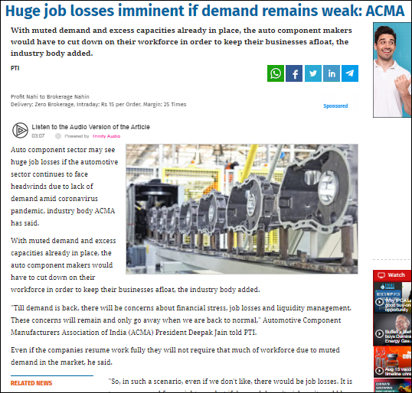
Publication – The Outlook
Headline- Auto industry bodies fear delay in imports clearance may impact vehicle production

automobile industry bodies SIAM and ACMA on Monday expressed concern over import consignments from China being subjected to manual inspection, saying that inordinate delays in clearance at ports could lead to disruption in vehicle manufacturing across the country. The industry bodies said such act is best avoided as the sector is limping back towards growth.
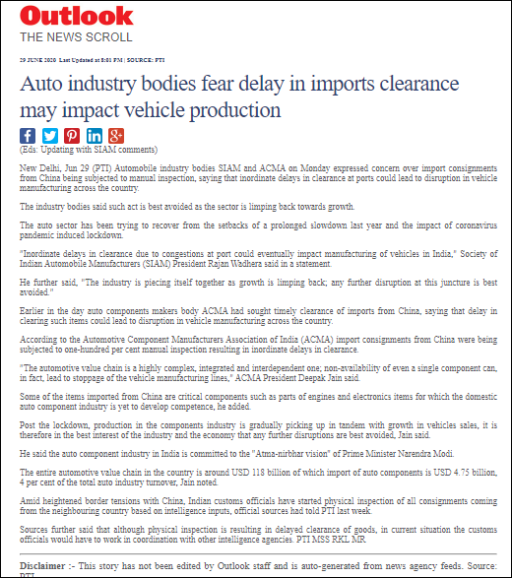
Publication – The Outlook
Headline- Indian auto component industry aims to cut dependence on Chinese imports: ACMA

The USD 57 billion-Indian auto component industry has started taking steps towards "deep localisation" to de-risk business from Chinese imports with the border dispute between the two countries only acting as a catalyst to speed up the process, according to industry body ACMA.
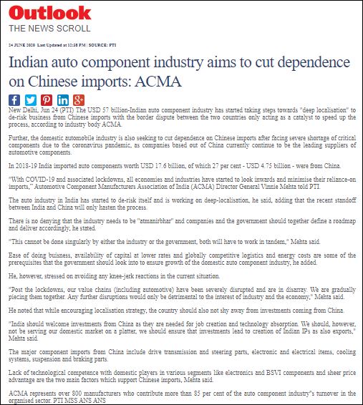
Publication – The Outlook
Headline- Huge job losses imminent if demand remains weak: ACMA

Auto component sector may see huge job losses if the automotive sector continues to face headwinds due to lack of demand amid coronavirus pandemic, industry body ACMA has said. With muted demand and excess capacities already in place, the auto component makers would have to cut down on their workforce to keep their businesses afloat, the industry body added.

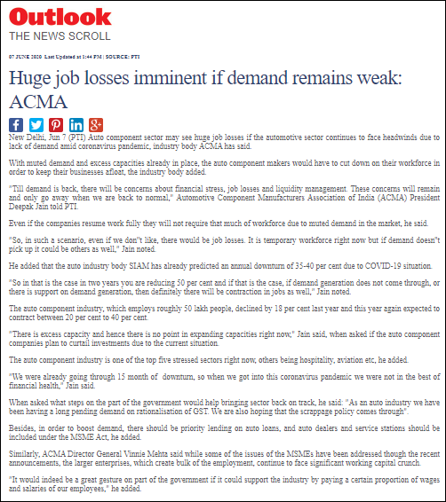
Publication – The Outlook
Headline-Auto component industry should aim for 5 pc of global trade in 5 years; govt support crucial: ACMA

The Indian auto components industry should look at enhancing exports and target at least 5 per cent of the total global trade, which stands at around USD 1.3 trillion, in the next five years, according to a top industry executive. For achieving such target, government support in terms of favourable policies would be crucial, Automotive Component Manufacturers Association of India (ACMA) Director General Vinnie Mehta told PTI.
.

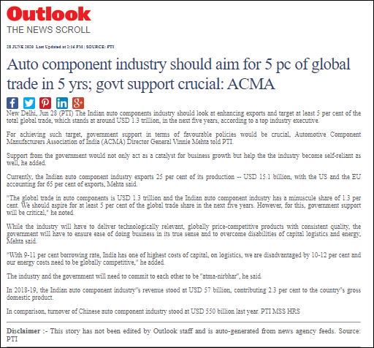
Publication – NDTV
Headline- India's Auto, Pharma Sectors Not Ready To Wean Off China

Days after a border clash with China this month in which 20 Indian soldiers were killed, New Delhi told firms to find ways to cut imports from China. But two big industries, automobiles, and pharmaceuticals, say this is easier said than done. Like many countries, India relies on China for products such as electronic components and drug ingredients because it cannot make them or source them elsewhere as cheaply, company and industry figures say.
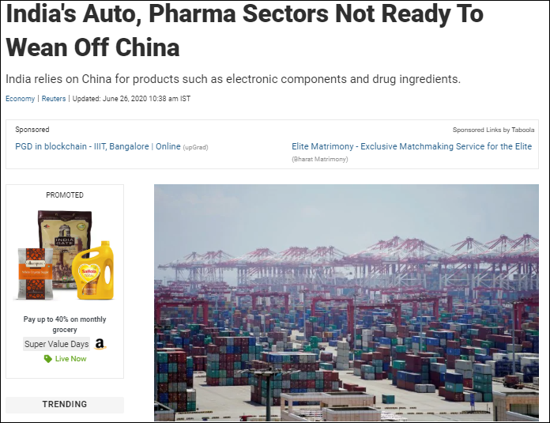

Publication – Express Drive
Headline- Deep salary cuts and job losses in India’s auto components industry
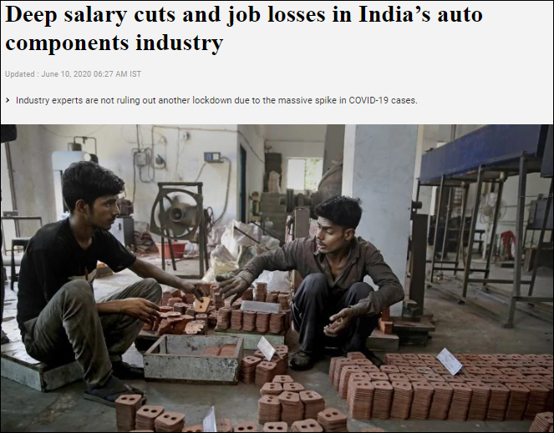
India’s auto components sector has an annual turnover of around USD 57 billion and employs 50 lakh people. Two months of lockdown have severely hit demand and the components industry has initiated deep salary cuts and most temporary workers have been laid off, said Vinnie Mehta, Director General, Auto Components Manufacturers Association.
Publication- News 18
Headline - Govt to Roll Out Incentives for Auto Companies to Double Exports in Next Five Years

The Department of Heavy Industries (DHI) has sought feedback from auto industry groups on the initial proposal, which suggests giving incentives over five years to increase local production and procurement for export, the sources said.

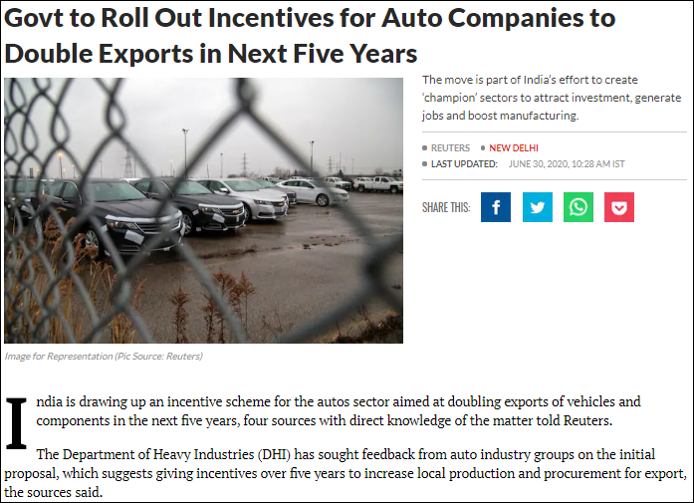

Publication – Times Now News

Headline Chinese imports held up at ports will disrupt supply chain: Indian auto industry

The ongoing tensions between India and China have had quite far-reaching consequences for various industries. Case in point: The Indian automotive sector, which has been severely affected due to imports from China being held up at ports. In fact, that was putting it mildly.

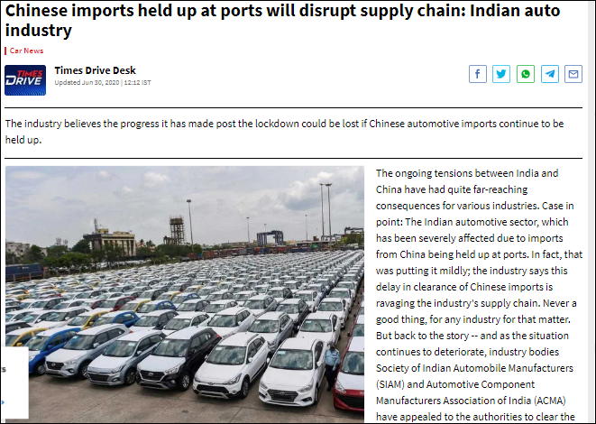

Publication – The Pioneer
Headline - ‘Delay in imports clearance may impact vehicle production’

Automobile industry bodies SIAM and ACMA on Monday expressed concern over import consignments from China being subjected to manual inspection, saying that inordinate delays in clearance at ports could lead to disruption in vehicle manufacturing across the country.
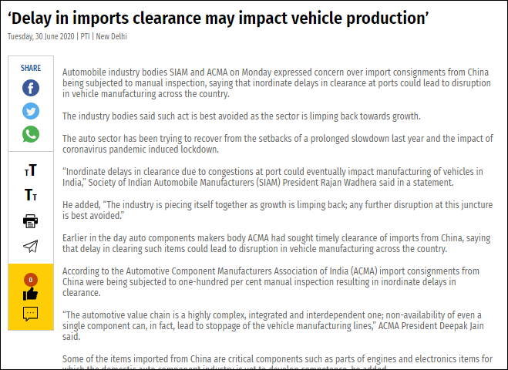

Publication – Deccan Hearld
Headline- Centre mulls ban on import of nonessentials from China

Annapurna Singh, DHNS, JUN 26 2020, 20:56 ISTUPDATED: JUN 27 2020, 11:08 IST Representative image Amid a widespread call to boycott Chinese products, the Centre is mulling restricting only non-essential imports from the neighboring country.

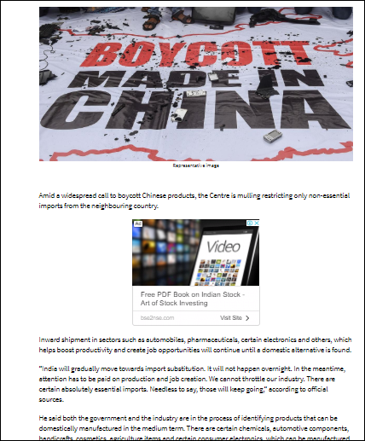

Publication – Deccan Chronicle

Headline- Huge job losses imminent in automotive sector if demand remains weak: ACMA

Auto component sector may see huge job losses if the automotive sector continues to face headwinds due to lack of demand amid coronavirus pandemic, industry body ACMA has said.
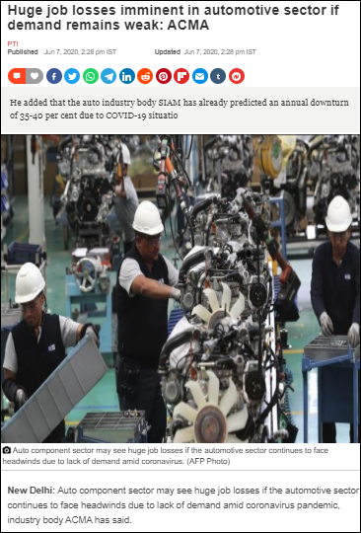
Publication – Telangana Today

Headline- Huge job losses imminent if demand remains weak: ACMA

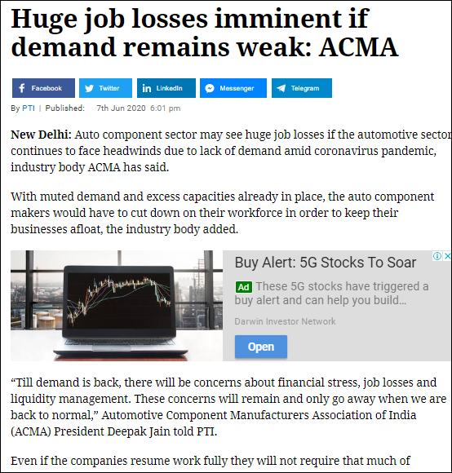
Auto component sector may see huge job losses if the automotive sector continues to face headwinds due to lack of demand amid coronavirus pandemic, industry body ACMA has said.

Publication – In Shots
Headline- Auto industry planning deep localisation to cut China imports: ACMA

The Director General of Automotive Component Manufacturers Association of India, Vinnie Mehta, said the industry has started planning steps towards "deep localisation" of business to reduce imports from China. India imported components worth $4.75 billion from China in 2018-19.
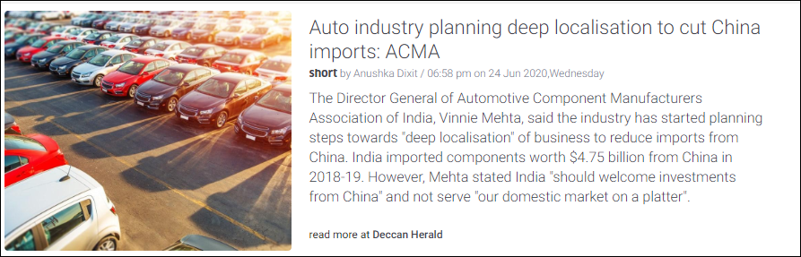

Publication – BS Motoring
Headline- Disruptions in Chinese imports will hurt their recovery: Automobile firms

The Indian automobile industry has sounded alarm bells over delays in Customs clearance for imports from China. The move, they said, would hurt the recovery of the industry, which has been reeling from the shock of a yearlong slowdown further worsened by the Covid-19 pandemic.
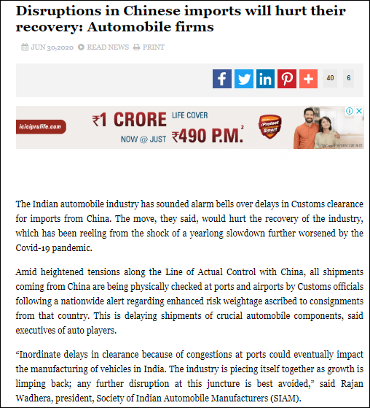
Publication – Auto Tech Review
Headline- ACMA, SIAM Call for Quicker Clearance of Chinese Imports

The Covid-19 pandemic has resulted increased scrutiny and a 100 % manual inspection of the import consignments from China. This has led to a new problem of inordinate delays in clearance and thus delay in production in the auto industry.

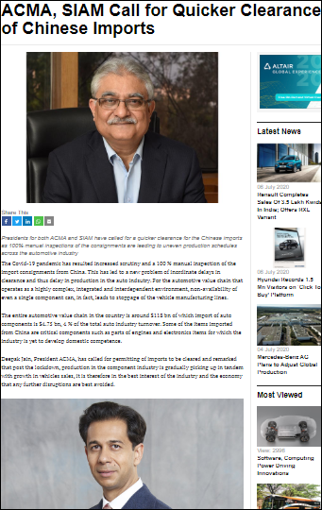
Publication – Auto Car Professional
Headline- ACMA and SIAM flag off supply chain issues due to delay in getting Chinese-made parts

It is understood that import consignments from China are being subjected to 100 percent manual inspection, which is resulting in inordinate delays in clearance. While there is no official government for such manual checks, the much-delayed consignments are bad news for India Auto Inc and the supply chain.

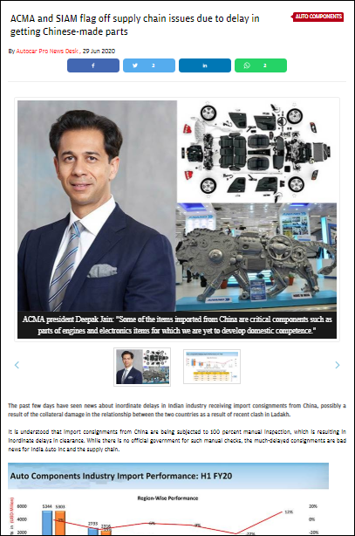
Publication – Auto Car Professional
Headline- Continuing headwinds for India Auto Inc could mean huge job losses: ACMA

The automotive component sector may see huge job losses if the automobile sector continues to face headwinds due to lack of demand amid the coronavirus pandemic, apex component supplier body Automotive Component Manufacturers Association of India (ACMA) has said.
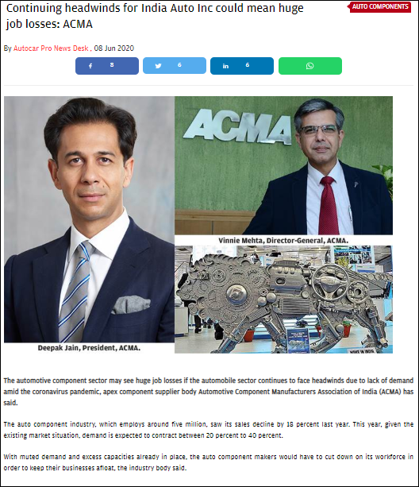
Publication – Car and Bike
Headline- Congestion Of Auto Components Imported From China May Lead To Production Delays

The Coronavirus situation has adversely disrupted the Indian auto industry. With an eroded supply chain, production has been dwindling and achieving sales targets has been a challenge. Moving forward things are expected to get even worse due to the delay of imported component clearances at Ports which eventually are expected to take a toll on manufacturing of CKD vehicles.

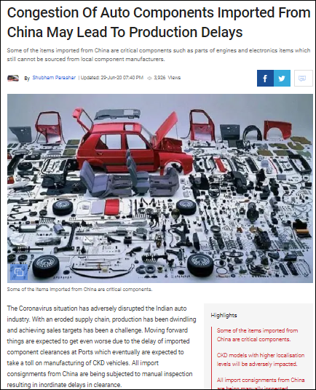

Publication – Rush Lane
Headline- Lakhs of jobs may be lost in auto component industry this year

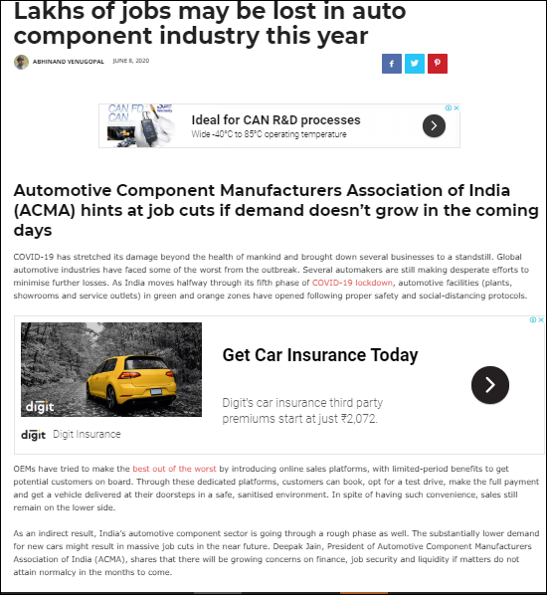
COVID-19 has stretched its damage beyond the health of mankind and brought down several businesses to a standstill. Global automotive industries have faced some of the worst from the outbreak. Several automakers are still making desperate efforts to minimize further losses. As India moves halfway through its fifth phase of COVID-19 lockdown, automotive facilities (plants, showrooms, and service outlets) in green and orange.

