Home Work Review
through Digital Forum

Review of Home Work for Lean Manufacturing Cluster for ER companies On
28th March 2020 through digital forum
(8 companies)
Mentor – Mr. Sushil Sharma
Counsellor – Mr. Sanjay Pal
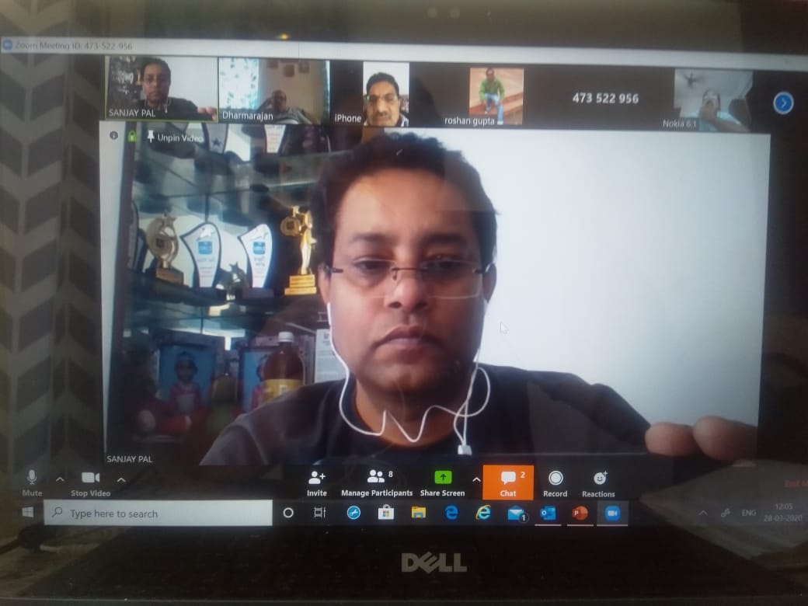
Review of Home Work for Uptime Improve Project at Wheels India Ltd., Rampur On
9th April 2020 through digital forum
(6 participants)
Mentor – Mr. Sushil Sharma
Counsellor – Mr. Vishal Saxena
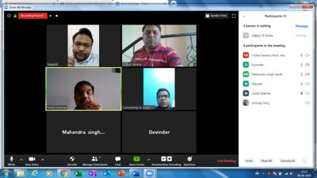
Review of Home Work for Uptime Improve Project at Wheels India Ltd., Rampur On
17th April 2020 through digital forum
(12 participants)
Mentor – Mr. Sushil Sharma
Counsellor – Mr. Vishal Saxena
