- Need to update the website word press version and the all the plugins. Also, I need the latest backup of the website.
- Home Page alignment issues in mobile and tabs. Also, mobile load speed in Google speed test tool shows 10, which need to be improvised. For, desktop as well, we need to fix the spacing issues.
- WP Rocket and CDN – need to check if it’s working fine or not for all sub domain. For few pages still the load speed is very high.
- Event page share option (I think we just need to copy the page theme and rename it as event page theme. In the event page we need to add the social share icon as it present in posts.)
- Home Page few Alt tags are missing

- Right sidebar is not proper in Healthcare subdomain - https://healthcare.mytechmag.com/
- Featured page is not leading content: https://www.mytechmag.com/featured
- For posts and CXO page, I could see the category name as mentioned in below examples. We can hide that (we can only keep the post date)
https://supply-chain.mytechmag.com/the-supply-chain-trends-to-look-out-for-in-2019-1230.html
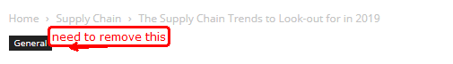
https://www.mytechmag.com/cxo-thoughts
