Delivering Breakthrough Results for Business Growth
Detailed Session-wise Schedule (2 Days)

Day 1
Sessions | Workshop Details | Pedagogy
9.30 am to 10.00 am | Welcome and Context Setting
10.00 am to 11.30 am | Session Theme: Unleashing Creative Confidence and Innovation  Potential
 | - Building creative confidence and connecting the dots  - Shifting reference points through cross industry examples: Breakthrough ideas v/s usual ideas  - Mindset Gravity: Introduction to Lock-in’s and how they condition our thinking and prevent coming up with new ideas  - Opening up the ‘New/Breakthrough Ideas’ Canvas: Where all are breakthrough ideas (innovation) possible?  - Innovation Types: Beyond Product, to Process, Service, Business Model, Ecosystem  - Innovation Levels: Function – Organization – Industry | Through ice-breakers to bring alive lock-in’s and experience ‘how we usually think’, followed by an interactive session with examples.
11.30 am to 11.45 am | Tea/Coffee Break
11.45 am to 1.30 pm | Session Theme: Introduction to Breakthrough Thinking and  Engagement, Ensuring thinking shifts
 | - Understanding the levels of thinking - Idea-frame-mental model: How recognizing and shifting frames & mental models helps in breakthrough ideas than mere random ideation  - Recognizing and streamlining modes of working: I(info) –N(new) –J(judge, decide)  - Delayering – How to move beyond a surficial viewpoint / opinion to deeper assumptions and generative dialogue | Through series of thought provoking and invigorating in-class exercises.
1.30 pm to 2.15 pm | Lunch Break
2.15 pm to 3.45 pm | Session Theme: Confronting Mindset Gravity and Breaking through  Mental Model Boundaries
 | - Group Activity – Innovation Challenge  - Confronting Mindset Gravities  - Prince Story – Breaking through Mental Model Boundaries | Deep immersions through reality map
3.45 pm to 4.00 pm | Tea/Coffee Break
Session Theme: Crafting Orbit Shifting Innovation and The Three Box
Solution
4.00 pm to 6.15 pm | - Crafting Orbit Shifting Innovation  - The Three Box Solution: A Strategy for Leading Innovation  - Why do companies need to continuously innovate?  - How can you identify market discontinuities that shape the future  - How can you build the requisite organizational DNA to create the  - Future while managing the present, especially Box 2&3 projects? | Insightful group activity on crafting  challenge
6.15 pm to 6.30 pm | First day closure and alignment on learnings with stakeholders
Day 2
Sessions | Workshop Details | Pedagogy
9.15 am to 11.00 am | Session Theme: Introducing Powerful Breakthrough Innovation tool – 3 Gear
Outdoor Group Activity and Reflections
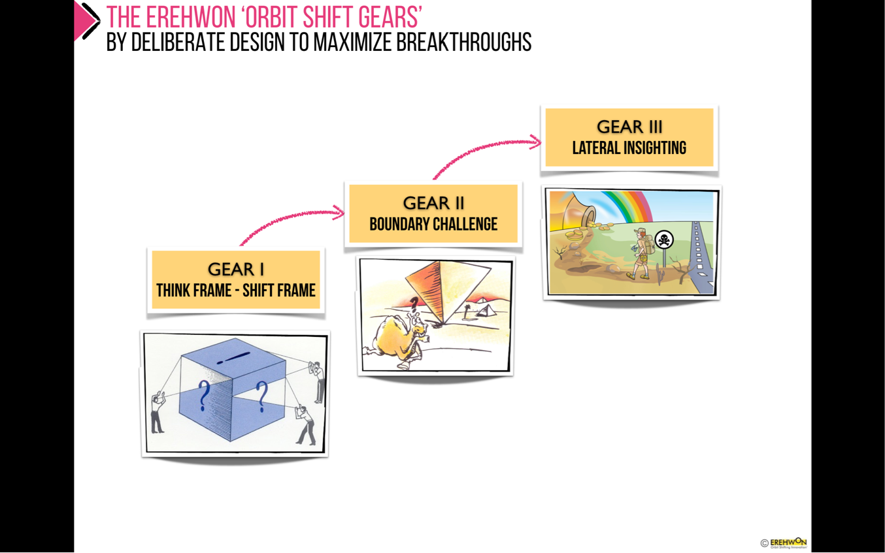
- 45 mins outdoor group activity
- Reflections by team leaders and team members
Breakthrough Thinking 3 Gear Tool
Gear 1 – Think Frame – Shift Frame
Gear 2 – Boundary Challenge
Gear 3 – Lateral Quest

(Series of workouts to master this tool)
11.00 am to 11.15 am | Tea/Coffee Break
11.15 am to 1.15 pm | Session Theme: Application of Orbit Shift Gears for Generating Breakthrough Insights and Ideas (Skilling)
 | Deepen learning of 3 Gears:  - How breakthrough happens by design with the help of 3 gears.  - Equipping with tools to get breakthrough results.  - Experiencing power of tool with exercises. | Through industry examples, in-class exercises and simulation.
1.15 pm to 2.00 pm | Lunch Break
2.00 am to 4.15 pm | Session Theme: Application of 3 Gears on Your Challenge and High Leverage Areas identification (Keystones) | Through working in breakout groups enabled by live facilitation in 1 independent round around the 3 situations (usually requires 3 rounds for mastering).
- Applying of the 3 Gears on LIVE challenge and coming up with a first set of breakthrough ideas.
One application round: Quick, fast-paced snap-application rounds, guided strongly by central facilitation.
- Round 1: Gear 1 Application: Think Frame - Shift Frame Consciously open up newer frames (Frame first, idea next)
- Round 2: Gear 2 Application: Boundary Challenge Map all current assumptions exhaustively, identify the limiting ones and challenge them by design to open up newer ideas
- Round 3: Gear 3 Application: Lateral Quest – A simple form – Fusion – Cross-fertilize from other industries/domains
4.15 pm to 4.30 pm | Tea/coffee break
4.30 pm to 5.30 pm | Session Theme: Leading Change through breakthrough innovations | Deep Insights and  Way forward
- Converting Innovation Ideas into Breakthrough Propositions
- How to disrupt your own thinking and lead innovation projects while getting best out of the teams across layers
- Prince Story Insights: How to approach change within the organization?
- Developing Execution Roadmap and Next Phase of Workshop
Closure and Feedback

Important Note: The faculty will ensure mindset shifts, leading with values and belief toward exponential future among participants throughout the workshop in every session.

