cid:b358cc71b24407be_0.0.1

**REGISTRATION FORM**

******

**ACMA** Scanned form to be sent: [**sapna.vijh@acma.in**](mailto:sapna.vijh@acma.in)

**6TH Floor,**  Mobile No. : +91-9873369063

**The Capital Court, Olof Palme Marg,**

**Munirka, New Delhi – 110067**

Dear Sir,

Our Company \_\_\_\_\_\_\_\_\_\_\_\_\_\_\_\_\_\_\_\_\_\_\_\_\_\_\_\_\_\_\_\_\_\_\_\_confirms participation at **Auto Technology Partnership Summit & Expo ( Physical )-“Exploring & strategizing India’s Global Integration”**, and would like to nominate the following personnel from our organisation.

Name\* Designation\* E-mail id\* Mobile Number\*

\_\_\_\_\_\_\_\_\_\_\_\_\_\_\_\_ \_\_\_\_\_\_\_\_\_\_\_\_\_\_\_\_\_\_\_\_ \_\_\_\_\_\_\_\_\_\_\_\_\_\_\_\_\_\_\_ \_\_\_\_\_\_\_\_\_\_\_\_\_\_\_

**Products Manufactured\*:**

**Products for Partnering \* (please mention below):**

**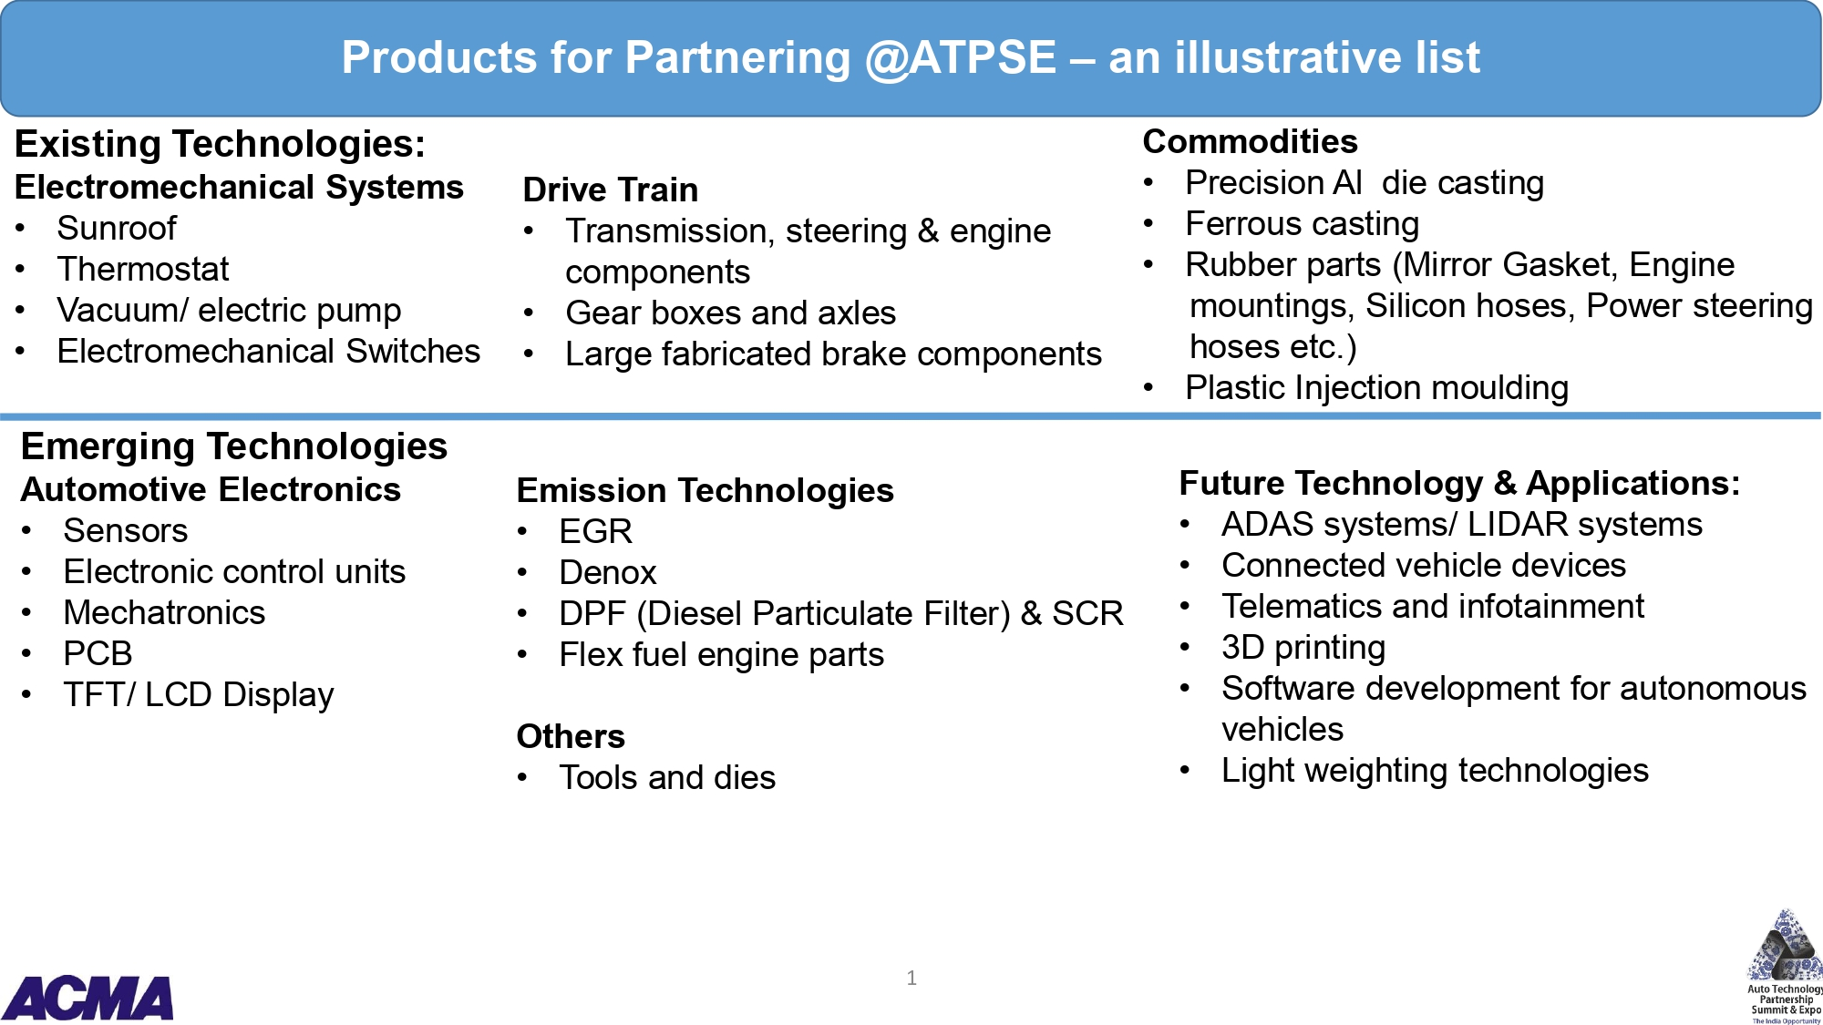**

|  |  |  |  |
| --- | --- | --- | --- |
| **S. No.** | **Type of Collaboration** | **Please tick (Any 2)** | **Area of interest with product group** |
| 1 | Seeking Technical Collaboration/ Joint venture |  |  |
| 2 | Explore export Opportunities |  |  |
| 3 | Seeking opportunity for other tie up (Contract manufacturing/ M&A) |  |  |
| 4 | Collaboration for EV components/ next generation mobility solutions |  |  |

**Please provide us with the following information of the company\*:**

IEC CODE: \_\_\_\_\_\_\_\_\_\_\_\_\_\_\_\_\_\_\_\_\_\_; PAN NO: \_\_\_\_\_\_\_\_\_\_\_\_; DIN NO: \_\_\_\_\_\_\_\_\_\_\_\_\_\_\_\_\_\_\_

**Cost of Participation: Annexure I**

**Member:** Rs.55,000/- + GST ( 18%)

**Non Member:** Rs. 65,000 + GST (18%)

**Deliverables:** 9 sq mt octonorm structure, fascia name, One round table, One info desk, three chairs, three spotlights, One wooden shelf, one podium, one waste-bin, one power socket, one info counter and carpet

**SPONSORSHIP OPPORTUNITIES**

**Cost:** Rs. 1,50,000/-

**Deliverables:**

* Standard booth (9 Sq mtr) at prime location
* 3 complementary Delegates.
* Colour advertisement in event catalogue ( inside insert )
* Logo in marketing collaterals : event website, inaugural backdrop and other branding areas
* 60 seconds corporate film on loop basis.

**Bank Details:**

|  |  |  |
| --- | --- | --- |
| DEMAND DRAFT / CHEQUE NO. \_\_\_\_\_\_\_\_\_\_\_\_\_\_\_Dated\_\_\_\_\_\_\_\_\_\_\_\_\_\_\_  AMOUNT: \_\_\_\_\_\_\_\_\_\_\_\_\_\_\_  (NON-REFUNDABLE)  TDS:\_\_\_\_\_\_\_\_\_\_\_\_\_\_\_\_\_\_\_\_ BANK:\_\_\_\_\_\_\_\_\_\_\_\_\_\_\_\_\_\_  DATED: \_\_\_\_\_\_\_\_\_\_\_\_\_\_\_\_\_  IN FAVOUR OF "AUTOMOTIVE COMPONENT MANUFACTURERS ASSOCIATION OF INDIA"  The transaction details to be shared to Ms. Sapna Vijh  ( sapna.vijh@acma.in) | | ACMA Bank detail for bank transfer :  Bank Account Name : Automotive Component Manufacturers Association of India  Account No. : 05882320000138  Bank Account Type: Current  Bank Name: HDFC Bank  Bank Address: R.K.Puram, Sector-4,New Delhi  MICR Code: 110240089  IFSC Code : HDFC0000588  UTRNO. \_\_\_\_\_\_\_\_\_\_\_\_\_\_\_\_\_ DATE:\_\_\_\_\_\_\_\_\_\_\_  AMOUNT:\_\_\_\_\_\_\_\_\_\_\_\_\_\_\_ TDS\_\_\_\_\_\_\_\_\_\_\_\_\_\_ |
| Invoicing Details | | | |
| Name |  | | |
| Designation |  | | |
| Company |  | | |
| Address on Invoice |  | | |
| Mobile no. |  | | |
| GST Number as per Invoice Address |  | | |

Coordinator’s Name\*: \_\_\_\_\_\_\_\_\_\_\_\_\_\_\_\_\_\_\_\_\_\_\_\_\_\_\_\_\_\_\_\_\_\_\_\_\_Designation\*: \_\_\_\_\_\_\_\_\_\_\_\_\_\_\_\_\_\_\_\_\_\_\_\_\_\_\_\_

Organisation\*: \_\_\_\_\_\_\_\_\_\_\_\_\_\_\_\_\_\_\_\_\_\_\_\_\_\_\_\_\_\_\_\_\_\_\_\_\_\_\_\_\_\_\_\_\_\_\_\_\_\_\_\_\_\_\_\_\_\_\_\_\_\_\_\_\_\_\_\_\_\_\_\_\_\_\_\_\_\_\_\_\_\_

Address\*: \_\_\_\_\_\_\_\_\_\_\_\_\_\_\_\_\_\_\_\_\_\_\_\_\_\_\_\_\_\_\_\_\_\_\_\_\_\_\_\_\_\_\_\_\_\_\_\_\_\_\_\_\_\_\_\_\_\_\_\_\_\_\_\_\_\_\_\_\_\_\_\_\_\_\_\_\_\_\_\_\_\_\_\_\_

Tel. No\*: \_\_\_\_\_\_\_\_\_\_\_\_\_\_\_\_\_\_\_\_\_\_\_\_\_\_\_\_\_\_\_\_\_\_\_\_\_\_\_ Fax No: \_\_\_\_\_\_\_\_\_\_\_\_\_\_\_\_\_\_\_\_\_\_\_\_\_\_\_\_\_\_\_\_\_\_\_\_\_\_\_

Mobile No\*: \_\_\_\_\_\_\_\_\_\_\_\_\_\_\_\_\_\_\_\_\_\_\_\_\_\_\_\_\_ E-Mail id\*: \_\_\_\_\_\_\_\_\_\_\_\_\_\_\_\_\_\_\_\_\_\_\_\_\_\_\_\_\_\_\_\_\_\_\_\_\_\_\_\_\_\_\_\_\_

Signature: ­­­­­­­­­­­­­­­­­­­­­­­­­­­­­­­­­­­\_\_\_\_\_\_\_\_\_\_\_\_\_\_\_\_\_\_\_\_\_\_\_\_\_\_\_\_\_\_ Date\*: \_\_\_\_\_\_\_\_\_\_\_\_\_\_\_\_\_\_\_\_\_\_\_\_\_\_\_\_\_\_\_\_\_\_\_\_\_\_\_\_\_\_\_\_\_\_\_\_\_

* Fields marked with \* are mandatory.
* The participation fee is non-refundable, however change in Nomination is allowed till two days before the program date.
* Re-Confirmation email will be sent by ACMA.
* Participants to represent the company booth must have complete dose of vaccination and send certificates along with the form
* All safety protocol for COVID-19 would be followed at the exhibition site