(Southern Region)

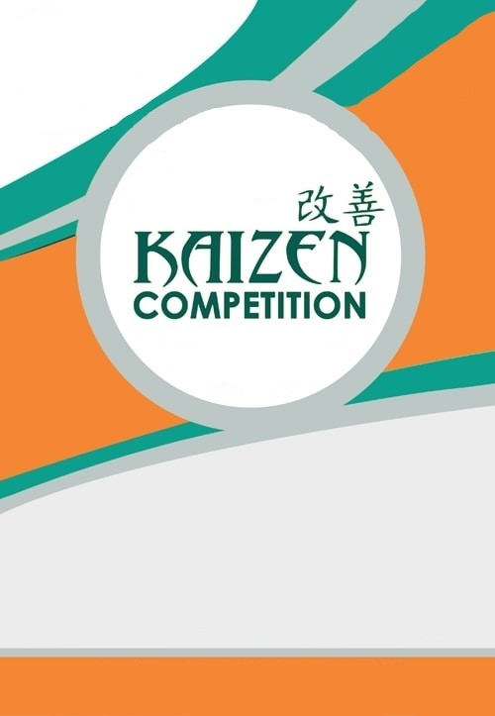
IN: HOTEL RADHA REGENT, CHENNAI
I
t
:
I :
i r i l
l r
r
i
it
i ti
it
i i l
it l i t t
If r ’ i t r j i r r
r
t
t l i t i l t i r r l
i
r t
i
t
r
f lit , r ti it , li r , f t
t
i r
fr
r
ill
r

11TH REGIONAL

CONTEST

ON: 21st DECEMBER
2019

ACMA SR is pleased to announce the 11h Regional Kaizen Contest scheduled
on 21st December, 2019 in Radha Regent, Arumbakkam, Chennai- 600 106 Who Should Participate??

Engineers/ Diploma Holders who have worked on kaizen with innovation & with minimal capital investments

If There’s no Kaizen to share come & join us as observers where you can take away some best examples as ideas to implement in your workplace

Kaizen can be presented in the areas of Quality, Productivity, Delivery, Safety & Cost 3 Winners from each area will be awarded

Participation Fee per person for Competition

Criteria | Member Fee | Non Member Fee
Large & Medium companies | Rs. 5000+ 18% GST | Rs. 6500+ 18% GST
SSI | Rs. 3000+ 18% GST | Rs. 5000+ 18% GST

Participation Fee per Observer
Criteria | Member Fee | Non Member Fee
Large & Medium companies | Rs. 2750 + 18% GST per delegate | Rs. 3500 + 18% GST per delegate
SSI | Rs. 2000 + 18% GST per delegate | Rs. 2750 + 18% GST per delegate

(Southern Region)

IN: HOTEL RADHA REGENT, CHENNAI
I
:
I :
,
I
Sponsoring:

You can also contribute to this Kaizen Movement as Sponsors

Co-Sponsor: Rs. 35,000 Logistic Sponsor: Rs. 25,000

To know more about sponsorship details refer to the enclosed reply form

Please Note:
The Kaizen sheets and presentations should reach ACMA office not later than, 6 Dec 2019. ➢Juries have decided to give weightage to presentations reaching on time.
➢For presentations reaching after deadline will not be awarded this weightage
➢Final presentation copy should reach ACMA Office Latest by, 13 Dec 2019, in a CD along with 2 colour printed sets of presentation.
➢Jury decision would be final.
➢Scores will not be shared with teams/individuals. ➢Maximum 3 participants per team.
Best Wishes & Regards, Encl: Reply Form, Eligibility Criteria, Guidelines, Format, Shuba Kumar Guide lines for Kaizen evaluation

11TH REGIONAL

CONTEST

ON: 21st DECEMBER
2019

