Annexure 1
Details of Certification Couse by ACMA Centre of Excellence – June 2020

S.No. | Course Name | Session Details and Schedule | Key Takeaway | Fees | Faculty
1 | Certification course on Techniques of Levelled Production | Session 1  27th June 2020, Saturday (3:00 PM to 4:30 PM) | Basics of Manufacturing, Types of mass manufacturing methods, material supply, layouts and supplier-customer relationships | Fees per Registration (Excluding GST)  - INR 4000/-  (For ACMA Members, ACMA-UNIDO Cluster members)  - INR 4400/-  (For Non-Members)  Unique Link for each virtual session will be shared with each participant | 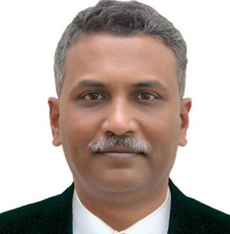  Mr. Girish Govande, Head Supply Chain Engagement, ACMA
 |  | Session 2  4th July 2020, Saturday (3:00 PM to 4:30 PM) | Batch type production, Types and methods of Level Production
 |  | Session 3  11th July 2020, Saturday (3:00 PM to 4:30 PM) | Line production and Level Production using Heijunka pattern
2 | Certification course on Communication & presentation Skills | Session 1  30th June 2020, Tuesday (3:00 PM to 4:30 PM) | Communication – Ways to improve Verbal / Non-Verbal communication skills | Fees per Registration (Excluding GST)  - INR 4000/-  (For ACMA Members, ACMA-UNIDO Cluster members)  - INR 4400/-  (For Non-Members)  Unique Link for each virtual session will be shared with each participant | Mr. V K Sharma, Head Cluster Programs, ACMA
 |  | Session 2  7th July 2020, Tuesday (3:00 PM to 4:30 PM) | Communication – Ways to improve written communication skills
 |  | Session 3  14th July 2020, Tuesday (3:00 PM to 4:30 PM) | Presentation – Ways to improve presentation skills

Certification:
A digital certificate of participation will be provided to all registered participants at the end of last session of the course. However, registration for a single session can also be made as per below mentioned fees:
– INR 2000/- (Excluding GST) for ACMA Members & ACMA-UNIDO Cluster members
– INR 2200/- (Excluding GST) for Non-Members

How to Attend: Please register with this link https://myenovation.com/webinar.html
Upon confirmation, separate link for joining each virtual session will be shared separately with each participant before start of every session.

