Annexure 1
Details of Certification Course by ACMA Centre of Excellence – July 2020

S.No. | Course Name | Session Details and Schedule | Key Takeaway | Fees | Faculty
1 | Certification course on Techniques of Leveled Production | Session 2  4th July 2020, Saturday (3:00 PM to 4:30 PM) | Batch type production, Types and methods of Level Production | Fees for each session per Registration (Excluding GST)  - INR 2000/-  (For ACMA Members, ACMA-UNIDO Cluster members)  - INR 2200/-  (For Non-Members)  For Academia - 50% discount on Non-Member Fees | 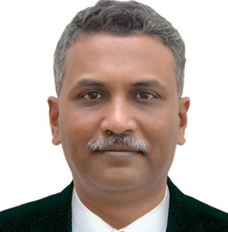  Mr. Girish Govande, Head Supply Chain Engagement, ACMA
 |  | Session 3  11th July 2020, Saturday (3:00 PM to 4:30 PM) | Line production and Level Production using Heijunka pattern
 | Certification course on Communication & presentation Skills | Session 2  7th July 2020, Tuesday (3:00 PM to 4:30 PM) | Communication – Ways to improve written communication skills  Etiquettes of written communication to have Impactful communication with customers and suppliers | Fees per Registration (Excluding GST)  - INR 2000/-  (For ACMA Members, ACMA-UNIDO Cluster members)  - INR 2200/-  (For Non-Members)  For Academia - 50% discount on Non-Member Fees | Mr. V K Sharma, Head Cluster Programs, ACMA
 |  | Session 3  14th July 2020, Tuesday (3:00 PM to 4:30 PM) | Presentation – Ways to improve presentation skills to keep people interested during presentation  3C: Clear, Concise, Competent is the key
3 | Certification course on “New Normal for future manufacturing” | Session 1  17th July 2020, Friday (3:00 PM to 4:30 PM) | Current business scenario and our response, New Normal for future manufacturing,  New skill requirements and processes to achieve New skills. | Fees per Registration for all 3 sessions (Excluding GST)  - INR 4000/-  (For ACMA Members, ACMA-UNIDO Cluster members)  - INR 4400/-  (For Non-Members)  For Academia - 50% discount on Non-Member Fees | 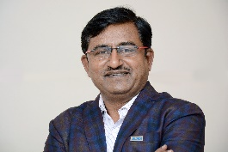  Mr. Dinesh Vedpathak, CEO, Skilling & Training, ACMA
 |  | Session 2  24th July 2020, Friday (3:00 PM to 4:30 PM) | Moving from Problem solving to problem killing, PPM to Defect culture, Inventory less production, quick measures, Air to air manufacturing, next levels of Single piece flow and flow manufacturing
 |  | Session 3  31st July 2020, Saturday (3:00 PM to 4:30 PM) | New decision-making skills, empowerment to bottom line, DVP's 25 wastes, Techniques to eliminate all kinds of losses from system,  Differentiating parameters between good and best in class companies. (Supported by tools and Techniques brief information)
4 | Certification course on “Staff Development Program – Groom Future Managers” | Session 1  30th July 2020, Thursday (3:00 PM to 4:30 PM) | Active Observation, consolidation and reporting method. Homework will be assigned | Fees per Registration for all 4 sessions (Excluding GST)  - INR 5000/-  (For ACMA Members, ACMA-UNIDO Cluster members)  - INR 5500/-  (For Non-Members)  For Academia - 50% discount on Non-Member Fees | Mr. Girish Govande, Head Supply Chain Engagement, ACMA
 |  | Session 2  6th August 2020, Thursday (3:00 PM to 4:30 PM) | Techniques of process refinement. Making lean and efficient process. Homework will be assigned
 |  | Session 3  13th August 2020, Thursday (3:00 PM to 4:30 PM) | Identify vital few, techniques of data capture. Data to be collected & homework will be assigned.
 |  | Session 4  20th August 2020, Thursday (3:00 PM to 4:30 PM) | Connecting both ends of hierarchy.  Assessment will be conducted for passing certification

Certification:
A Digital Certificate of participation will be provided to all registered participants at the end of all sessions of the course. Registration for a single session can also be made as per below mentioned fees:
– INR 2000/- (Excluding GST) for ACMA Members & ACMA-UNIDO Cluster members
– INR 2200/- (Excluding GST) for Non-Members

How to Attend: Please register with this link https://forms.gle/KTnc24WGo82Kv4bq6
Upon confirmation, separate link for joining each virtual session will be shared separately with each participant before start of every session.

